Options for using a course code to record attendance.

Option 1: Instructions for the learner to submit course code by SMS Text:
- *To receive credit for this activity, text the code: [XXXXXX]to 412-312-4424 by [Insert Date]
- To access your credit transcript and certificate choose My Activities, Pending Activities
* New users will receive instructions to create an account.
Note(s):
- Instructions may vary depending on the format of the activity.

- If the learner does not have an account, the following SMS message will be sent to the learner to check to confirm that the leaner does not have an account that is not associated phone number used (i.e., learner is using a different phone).
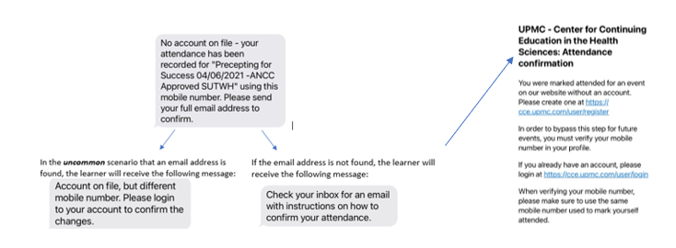

Option 2: Instructions for the learner to submit course code by link:
- Before [Insert Date], go to http://cce.upmc.com/code
- *Login to your account
- Submit attendance code [XXXXXX]
- To access your credit transcript and certificate choose My Activities, Pending Activities
* If you are a new user, click Register to create an account.
Note(s):
- Instructions may vary depending on the format of the activity.

