Please join us for a virtual CEU Live Event. Click the link below to join:
To join CLICK HERE

This is a 2 hour CEU. We will take a brief 10 minute break about half way through.
The only way to access the meeting is through the link above via website (Chrome or Microsoft Edge Chromium) or Microsoft Teams. There is no call in number.
Once you join, you will be automatically muted.
Please make sure your computer audio is turned up.

When submitting a question:
Please submit using the Q&A feature and begin your question with your setting so that we can answer appropriately.

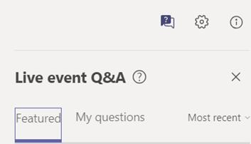

To receive continuing education credit, you will need to return to your Center for Continuing Education account and complete the course evaluation. CME and CNE certificates will be available immediately. SW and PCHA certificates will be emailed separately.

For questions regarding this invitation, please contact Chrissy Meduho at meduhoc2@upmc.edu

