Instructions to view course reports

Please note, the following instructions are for viewing course reports only. It does not include managing enrollments (i.e., recording/editing attendance).

- Access the course by clicking on the course in the catalog or the direct link. Note: your CCEHS contact should provide you the direct link to the course.

- Choose Course Reports

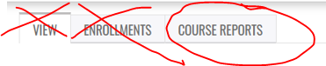

- Overview
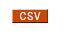
This is a list, including the status, of everyone who is enrolled in the course and has an account. You can export to Excel by clicking at the bottom of the page.

Note: This list does not include imported records for learners who did not create an account.

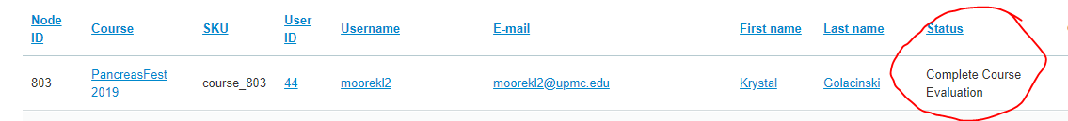

- Course Evaluation Data and Analysis
To view the course evaluations and analysis, from the green banner, you can choose “Course Reports”, “Course Objects”, “Course Evaluation” and any of the options. “Analysis” will provide a summary.
Choose to save a copy.

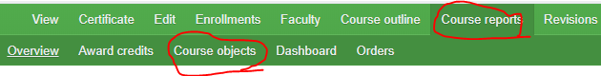

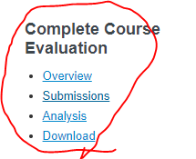
- Dashboard
The dashboard provides a variety of reports with hyperlinks to download.

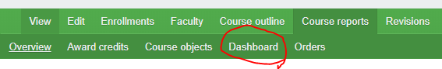

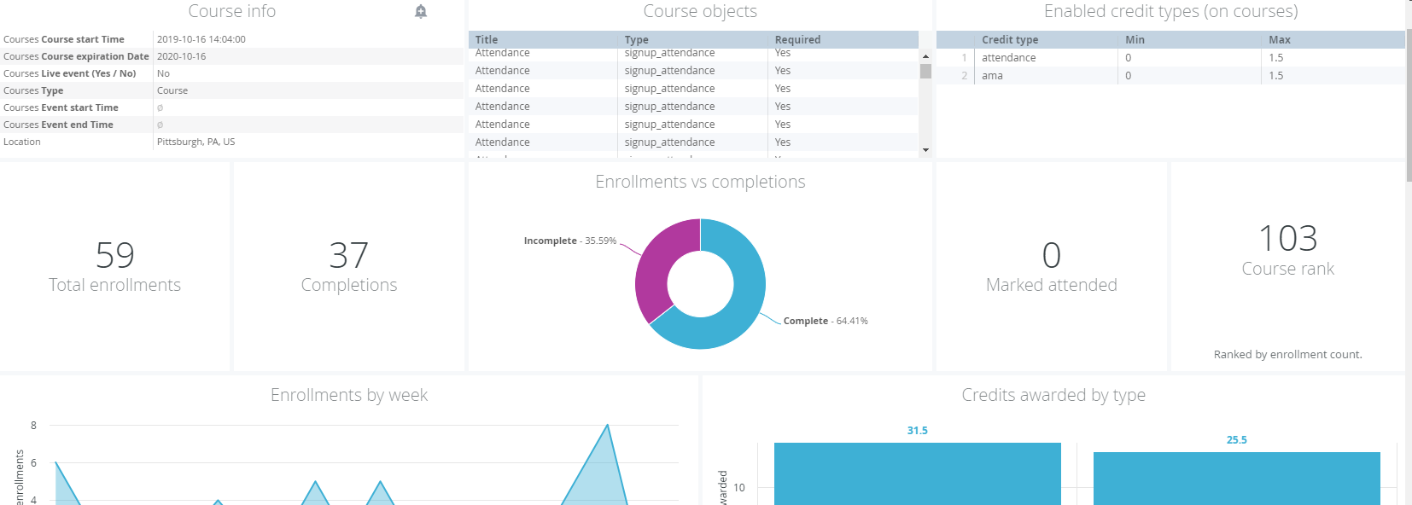

- Orders

“Orders” to see the amount paid and order status. Note: The meaning of the status column is listed below.

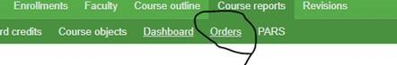
Order Statuses:
- Abandoned: Learner went through EthosCE checkout to the hosted payment checkout page and did not complete their order. Order is in limbo until learner completes checkout.
- Canceled: Site administrator can manually set an order to 'Canceled.' A canceled order does not automatically unenroll a learner from a course. The unenrollment would have to be done manually.
- In checkout: Learner is on the EthosCE checkout page and has not completed the checkout process.
- Completed: Orders with a successful credit

