Instructions: Updating Credits via Award Credits in a Course or Session
- Navigate to the course or session, then choose ‘Course reports,’ then ‘Award credits.’
- Check the box(es) to the left of the user(s) name(s) you want to update. Please note, selecting more than one user will perform the same action to all of the users selected.
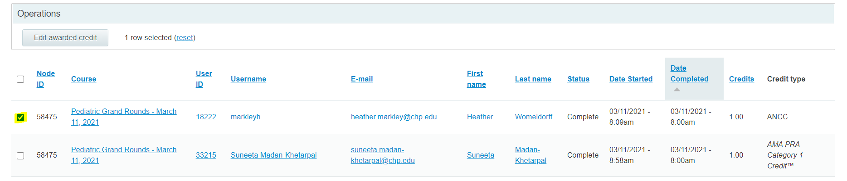
- Click the ‘Edit awarded credit’ button.
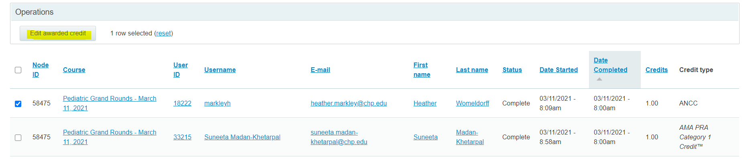
- Select the arrow to the left of the credit type to add, remove or modify that credit type for the user(s) selected.
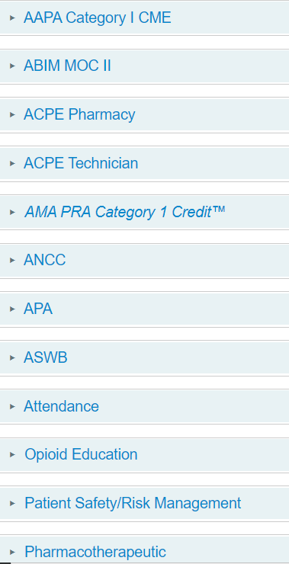

- Choose the appropriate action from the options and input the correct credit amount in the ‘Credits’ field. You should not have to input the ‘Date awarded’ unless the date is wrong or you’re initially awarding credits.
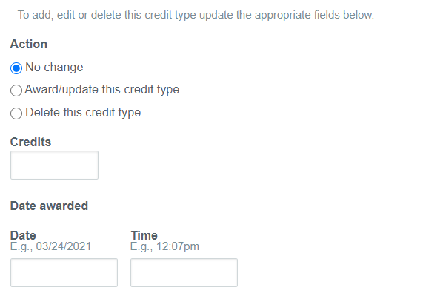
- Click the ‘Next’ button at the bottom of the screen.
- Click the ‘Confirm’ button.

