Enrollment (Managing Attendance)
Importing
Importing is a tool than can be used to import attendance using an Excel spreadsheet. Records are matched to users by email address.
Important note: It is acceptable to import attendance records for learners who have not created an account. If an attendance record is imported and no matching user account is found, the records would be placed into a holding table until a learner with a matching email address creates an account. At the time the learner creates the account, the imported record pertaining to the matched learner would then be assigned to the learner. You cannot upload multiple courses using 1 spreadsheet.

Step 1- Access your Course.
Step 2- Click on Enrollments.
Step 3- Click on Import.
- Download the template (or use a previously saved version).
Note” Do not make changes to the default settings.
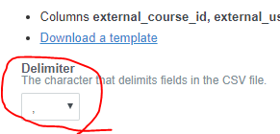
Note: Must be “,”

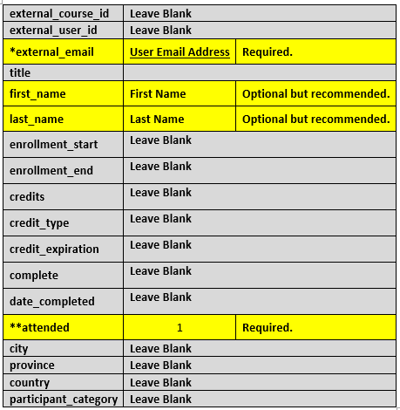
- The spreadsheet will include the following fields. Enter the highlighted fields as listed below:

* Records are matched to users by email address
**You must enter a “1” in this field or the learner will not receive credit.
Tip: It is easier to look-up attendance records if you enter a first and last name.

Below is an example of a completed spreadsheet:
- Once you have everyone entered in the document, save to your computer (you will need to access the saved spreadsheet in the next step). Important Note: Do not change the file type. It must be a file type.

- Under “file” click Choose File and upload the document.
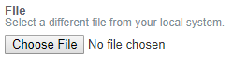
- Check the box at the bottom “Assign records immediately” and “Import”.
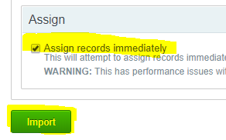
- Once imported, a message will display on the screen.

Success Example:
Failure Example:
- To view imported record, choose Imported Records.
