RSS TRAINING
Enrollment (Managing Attendance)
Introduction to Managing Attendance
Enrollment is the process for recording attendance. The new system is “Account-based” meaning that every learner will need to access/create an account at http://cce.upmc.com. There are three options for recording attendance:
- *Pre-registration (Ethos) (only prior to the start date for a live activity)
- Importing (Excel Spreadsheet)
- Search and Enroll (Manual Entry)
- SMS Texting

Notes:
*ALL three options are available for each session. For example, you can use Importing but still use the Search and Enroll tool for the same activity.
* A learner will not be able to enroll for a live activity after a live activity has started.

View and Edit Attendance Records
The course contact has the ability to view and edit attendance records for each session. For example, if a learner is inadvertently enrolled, the course contact can remove the enrollment.
Step 1: Go to Administer. View list of all learners.

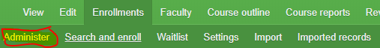
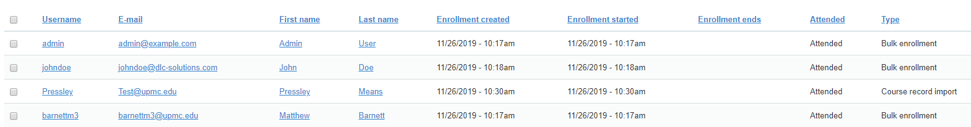
Step 2: To edit enrollments, type in any part of their first and/or last name and/or email.
- Once their name appears place a check mark in the box of the record you are editing.

- Once they are selected, choose the relevant option.

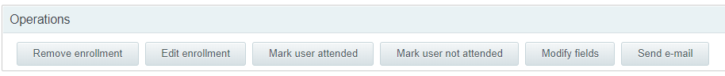

Important Note: The list includes all learners who have an account and have been awarded credit for this session (entered by Pre-registration, SMS text, Importing, and/or Search and Enroll).

Tip: If you are looking for a learner who was imported but is not listed in the “Administer” tab, it is likely that the learner did not create an account.

