Enrollment (Managing Attendance)
Search and Enroll
The Search and Enroll feature can be used to manually record a learner’s attendance.
- You will be able to enroll any user this way, but they must already have an account created.
- This is a good option for enrolling a few learners, but, time consuming if you are enrolling a large number.
- You must enroll the learner AND mark the learner as attended.
Step 1- Access your Course.
Step 2- Click on Enrollments.
Step 3: Click on Search and Enroll.
- Type in any part of their first and/or last name and/or email. Reminder: the learner must have an existing account to use “Search and Enroll”.
- Once their name appears place a check mark in the box and click “Enroll user”.
Reminder: you must also mark the learner as attended (next step).
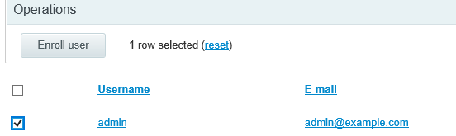
- Check the box to select all the enrolled users, once they are all selected, click mark user attended.
