**Maria Kolcharno, The Wright Center**

**Response to Questions asked at PA PQC 9/14 Learning Session**

**COE Panel Discussion**

______________________________________________________________________________________________

* **What services does your COE provide for pregnant/postpartum individuals with OUD? What does this look like from the patient’s perspective once the patient is referred by an OB/GYN, for example? And what is the eligibility criteria?**

1. Program Description

Healthy MOMS

The Healthy MOMS collaborative, is based on the Maternal Opiate Medical Supports (MOMS) model, through the State of Ohio. The goal of the program is to improve maternal and fetal health outcomes, improve family stability, and reduce costs of Neonatal Abstinence Syndrome (NAS).

The Healthy MOMS program will provide treatment to pregnant mothers with opiate use disorder/substance dependency during and after pregnancy through a Maternity Care Home (MCH) model of care. The MOMS model is a team-based healthcare delivery model that emphasizes care coordination and wrap-around services engaging expecting mothers in a combination of counseling, MAT, and case management.

No women will be discriminated against based on ethnicity, race, and color of skin, age, sexual orientation, religious preferences, gender identity, marital status, nationality, disability, or handicap.

**Eligibility to participate in the Program**

1. No patient will be declined participation into the program on the basis of ability to pay for care.

2. The patient has been identified with a confirmed pregnancy, or have recently given birth.

3. The women has a diagnosis of Opioid Use Disorder, or Substance abuse disorder.

4. The women has agreed, and signed consent to participate in program.

5. Each woman will have the ability to choose their providers for MAT, OBGYN, and Primary care. If the patient does not have a confirmed provider identified, the team will offer suggestions and the patient always has the ability to choose providers.

6. Each woman must be involved or have recently successfully completed a MAT program or Substance abuse program addressing her opioid or Substance Use dependence needs.

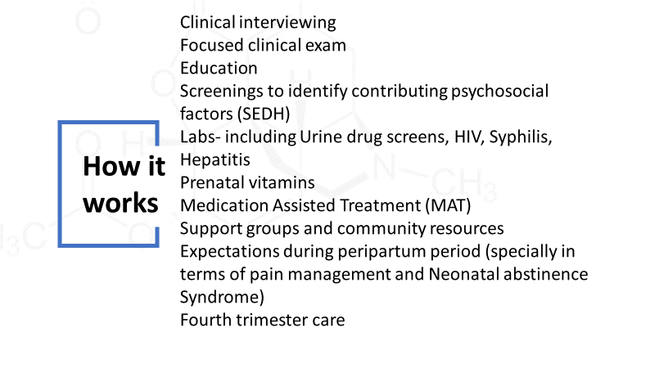

*Healthy MOMS provide intensive case management services to pregnant women with OUD/ SUD throughout their pregnancy up until the time their youngest child is two years old. The program is aimed at stabilizing this high-risk population and allowing them to receive the necessary supports to manage their chronic condition in conjunction with pregnancy and the postpartum period. Many of the mothers involved in the program are considered high-risk pregnancies because of their prescribed MAT (buprenorphine, methadone). The intensive case management service works to provide an array of services by linking this high-risk population with collaborative community partner resources. Areas addressed throughout the program include:*

*MAT (if necessary)*

*linkage to inpatient treatment programs (if necessary)*

*referrals to and monitoring of family planning service, including OB, high risk Maternal Fetal Medicine, LARC after birth, as well as social services like WIC.*

*referrals for both mother and child health needs, including PCP, pediatrician, Hep C, and any required specialists*

*services aimed at supportive housing to promote safe, permanent, sober housing*

*services aimed at eliminating barriers to transportation so that mother and child can attend all necessary appointments consistently*

*services aimed at coordination of social services (CYS, legal issues)*

*A Certified Recovery Specialist is also involved as part of the case management team in order to provide peer support towards management of their chronic condition of SUD.*

*_______________________________________________________________________________________________*

* **How has your COE successfully collaborated with birth hospitals and/or their OB/GYN outpatient clinics to engage pregnant/postpartum individuals with OUD in COE services? How were these working relationships developed? And what has worked well in terms of the role of the maternal setting and the role of the COE to ensure engagement in services following a referral? (Note: If MAT engagement/retention data is available, feel free to include that as well.)**

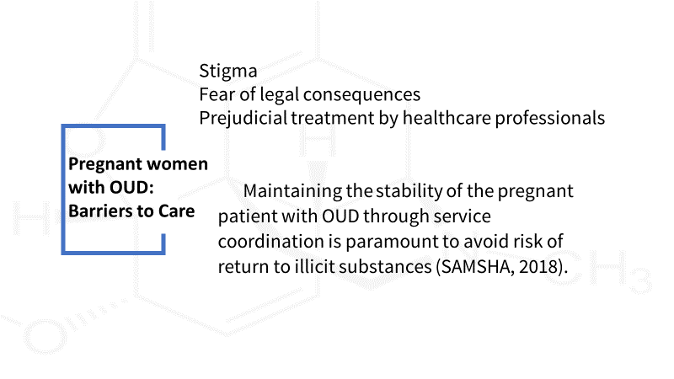

*First, we visited the maternity units at the hospital to explain the program, discuss the best workflow for the specific setting. I believe to really become a working part of a program we must submerge ourselves into their program.*

*Then we offered Grand rounds at each specific hospital to speak about Stigma, MAT and the workflow. We reviewed a case presentation so we could show the workflow through a case.*

*I made arrangement to meet with each of the nursing shift to discuss stressors and the stigma our MOMS fear going to the labor and delivery. We wanted to confront stigma some of the nurse’s experience. Most hospital had shared very openly their conceptions and misconceptions regarding SUD/OUD. After a couple sessions the nurses began to discuss they wished the moms could “know they support them” and they asked for HM pins to wear on their uniforms so the moms know they are part of the team. 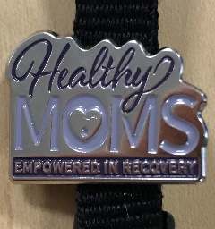*

* **What suggestions do you have for other maternity care providers and COEs to replicate this type of collaborative working relationship and referral process?**

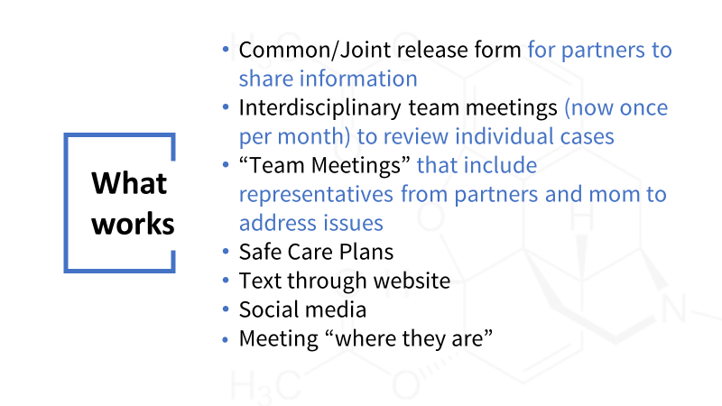

**Healthy Moms Work Flow for Data Collection**

*During the first Visit with the prospective participant all releases of information are signed for the following Healthy MOMs Collaborative for enrollment into the program, OBGyn, hospital (labor and delivery), legal system, Drug/Alcohol provider, MH provider or any other pertain/ necessary parties to assist the Healthy MOMs patient in the program. Chart is created in Medent appointment is scheduled.*

*Case manager completes Medent HM Client screening (PCS-HMSCRE). Complete HM progress note (COE-MOMS), SEDH, ACE the perception of outcomes and Healthy MOMs intake document.*

*Case manager meets with each Healthy Mom bi-weekly unless additional appointments are required. For each encounter a HM progress note is completed. (COE-MOMS-COE-Healthy MOM contact).*

*The MAT physician will meet with participants of the Healthy MOMs program seeking MAT care. The pregnant patient is a priority population, every measure will be taken to provide services within the allotted time. The physician will follow the MAT process listed below:*

*1. The Induction Phase is the medically monitored startup of buprenorphine treatment performed in a qualified physician’s office or certified OTP using approved buprenorphine products. The medication is administered when a person with an opioid dependency has abstained from using opioids for 12 to 24 hours and is in the early stages of opioid withdrawal. It is important to note that buprenorphine can bring on acute withdrawal for patents who are not in the early stages of withdrawal and who have other opioids in their bloodstream.*

*2. The Stabilization Phase begins after a patient has discontinued or greatly reduced their misuse of the problem drug, no longer has cravings, and experiences few, if any, side effects. The buprenorphine dose may need to be adjusted during this phase. Because of the long-acting agent of buprenorphine, once patients have been stabilized, they can sometimes switch to alternate-day dosing instead of dosing every day.*

*3. The Maintenance Phase occurs when a patient is doing well on a steady dose of buprenorphine. The length of time of the maintenance phase is tailored to each patient and could be indefinite. Once an individual is stabilized, an alternative approach would be to go into a medically supervised withdrawal, which makes the transition from a physically dependent state smoother. People then can engage in further rehabilitation— with or without MAT—to prevent a possible relapse.*

*Once the MAT process has begun the Physician will review the pre-visit planning checklist (PVP-cklist) completed by the case manager or medical assistant for the Healthy MOMs program. The physician will meet with all participants in the Healthy MOMs despite involvement with other MAT or SUD care. During this appointment a medical and OBGyn history will be reviewed. A urine screen will be obtained.*

*Once the Healthy MOM has delivered her child a chart will be created in Medent for the baby by HM case manager.*

Below is the measurement tool built using SDOH, ACE, ASAM tools

|  |  |  |  |  |  |  |
| --- | --- | --- | --- | --- | --- | --- |
| Modality of care | Scale of Autonomy for Healthy MOMS Program | | | | | |
|  | 0 | 1 | 2 | 3 | 4 | 5 |
| MAT | Caregiver has been referred but not yet begun treatment | Caregiver has completed intake and is receiving high level of intervention | Biweekly meetings with case manager and/or doctor. If UDS are available, caregiver has not failed a urine test within 3 to 6 months | Biweekly/monthly meetings with case manager and/or doctor. If UDS are available, caregiver has not failed a urine within 6 months to 12 months | Biweekly/monthly meetings with case manager and/or doctor. If UDS are available, caregiver has not failed a urine test for over 12 months | A) Successfully completed treatment or discharged under positive conditions  B) Caregiver is not a part of a MAT program. |
| Psychiatric services  Emotional ,Behavioral  ACE Scores | A) Caregiver has been referred but not yet begun treatment  B) Caregiver refuses services | Caregiver has completed intake | A) Caregiver has shown short term success in treatment  B) Caregiver is noncompliant regarding treatment | Caregiver is actively participating in mental health services and has been compliant with treatment plan for 3 to 6 months | Caregiver is willingly engaged in treatment, has shown a long term pattern of being a compliant and active participant in their own mental health | A) Successfully completed treatment or discharged under positive conditions  B) Psychiatric services are not necessary |
| Physical health | Caregiver has had no medical care for condition(s) that require attention | Medical care has been established | Caregiver is receiving care and has severe medical problems or medical problems that need active monitoring | Caregiver has been receiving continued care and is in stable condition | Caregiver has been receiving care for any condition that is not detrimental to daily activities | Caregiver has no physical complications |
| Medical Access | Family has no access to routine medical care | A) Family has inadequate insurance  B) Family has adequate insurance but has no PCP or specialty doctor | Family has inadequate insurance and access to only primary care | Family has inadequate insurance and access to both primary care and specialty care | Family has adequate insurance and access to any medical care but may be limited by circumstance (high cost of care, lack of availability of services, inability to take time off work) | Family has access to any necessary medical care without any undue burdens |
| Drug & Alcohol care and treatment | Caregiver has been referred but not yet begun treatment | Caregiver has completed intake | A) Caregiver has been inconsistently compliant  B) Caregiver is noncompliant regarding treatment | A) Caregiver has consistently been compliant with treatment plan for 6 to 12 months  B) Caregiver has been compliant with treatment plan for less than 6 months | A) Caregiver has consistently been compliant with treatment plan for over 12 months | A) Successfully completed treatment or discharged under positive conditions  B) Caregiver does not need D&AS services |
| Professional support (CRS) | Caregiver needs peer support and is not receiving aid | Caregiver has been informed of support services | A) Caregiver has infrequently utilized support  B) Caregiver has just begun utilizing support services | Caregiver has been routinely utilizing support services and is able to cope with daily life with a moderate degree of difficulty | Caregiver has support and is able to cope with daily life with mild/low levels of difficulty | Caregiver has a supportive environment or is able to cope with current support levels |
| Readiness to change | Caregiver is in the pre- contemplation stage | Caregiver is in the contemplation stage | Caregiver is in the preparation stage | Caregiver is in the action stage | Caregiver is in the maintenance stage | Caregiver has embraced the action stage. |
| Relapse potential | Caregiver has shown a pattern of relapse | A) Caregiver has recently relapsed  B) Caregiver is at high risk of relapse | A) Caregiver has not relapsed within the past 3 to 6 months  B) Caregiver is at medium - high risk of relapse | A) Caregiver has not relapsed within the past 6 to 12 months  B) Caregiver is at medium - low risk of relapse | A) Caregiver has not relapsed in over 1 year  B) Caregiver is at low risk of relapse | Caregiver has no or minimal risk of relapse |
| Public Assistance Programs (WIC, CHIP, LIHEAP, etc.) | Caregiver needs aid and is not enrolled in any PAP | Caregiver has completed the process of applying for PAP | Caregiver has begun to utilize PAP | Caregiver is reliant on PAP for day-to-day living | Caregiver is able to cover expenses and is currently utilizing PAP | Caregiver no longer needs PAP |
| Clothing | Caregiver is unable to adequately provide clothing for themselves or their child and is not receiving support | Caregiver is unable to adequately provide clothing for themselves or their child and has been referred to support programs | Caregiver is unable to adequately provide clothing for themselves or their child and is receiving aid | Caregiver is reliant on aid to provide clothing for themselves or their child | Caregiver is receiving aid and is able to adequately provide clothing for themselves and their child. | Caregiver no longer needs services. |
| Food | Caregiver is unable to adequately provide food for themselves or their child and is not receiving support | Caregiver is unable to adequately provide food for themselves or their child and has been referred to aid programs | Caregiver is and receiving aid and is still unable to adequately provide food for themselves or their child | Caregiver is reliant on aid to adequately provide food for themselves and their child | Caregiver is receiving aid and able to adequately provide food for themselves and their child without aid | Caregiver does not need food aid and is not receiving aid |
| Housing | Caregiver is at immediate risk of homelessness and is not receiving assistance finding shelter | Caregiver is in a temporary housing situation or is on a month-to-month basis | Caregiver is receiving aid and has been in a stable housing situation for >3 months | Caregiver is receiving aid and has been in a stable housing situation for >6 months | Caregiver is receiving aid and has been in a stable housing situation for >12 months | Caregiver no longer needs aid |
| Access to transportation | Caregiver has no access to any means of transportation and no ability to get a license | A) Caregiver has no transportation but has the ability to get a license  B) Patient has a license but no access to transportation | Caregiver is relying on outside aid (bus cards, paid taxis) and either has a license or the ability to get one | Caregiver has a means of transportation that relies on family/friends and either has a license or the ability to get one | Caregiver has a license but not consistent access to a vehicle | Caregiver is autonomous and can travel without barriers |
| Social support | Caregiver has no familial or formal social support and is not attending groups | Caregiver has been informed of groups | Caregiver has begun to attend groups | Caregiver has developed a social support foundation and has been routinely attending groups | Caregiver has a stable social support system and is attending groups | Caregiver has a stable social support system and no longer attends groups |
| Parenting Education | Caregiver needs education regarding childcare | A) Caregiver has been given educational materials for parental competency skills  B) Caregiver refuses to participate in parental education | A) Caregiver has recently begun to utilize educational materials  B) Caregiver has implemented very little of the suggested changes | Caregiver has been actively participating in improving parental competency skills and has implemented some of the suggested changes | Caregiver has been actively participating in improving parental competency skills and has successfully implemented most suggested changes | Caregiver has adequately demonstrated all parental competency skills and is able to take care of the child |

Healthy MOMS Program stages

1 point per level of care, level 5 is worth 5 points, 0 is worth 0

Phase A) Intake phase less than 30 points

Phase B) Above 30 points and prenatal

Phase C) Above 45 points and postpartum

Phase D) Health MOMs services no longer required