Masquerading
This feature is the best option for viewing a user’s activities.
- From the wrench, choose “Manage Users”
- Find the user to masquerade as and click the user’s ID
- View the user’s profile (defaults here when you click the user’s ID)
- Click "Masquerade as [user]”
- 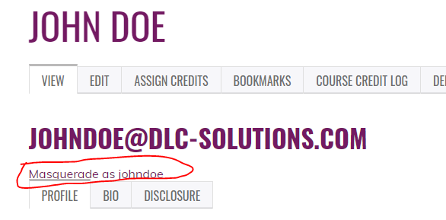
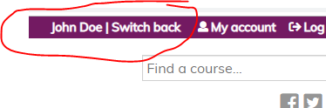
- To switch back, choose “Switch back” at the top of the screen

