Navigating EthosCE (The Wrench)
Ethos Support: Used to find instructions for specific tasks/features.

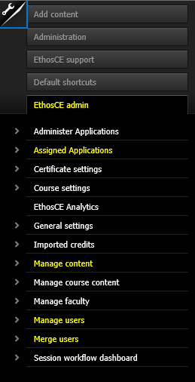
Add Content: This is the starting point for creating a Course or a Series without a course application.

EthosCE admin: This is you.

List of the applications assigned to you.

“Manage Content”: Used for finding courses.
1. Search by title, filter by content type (course, news item, page, etc.), and search for published/unpublished content.
2. Click “Apply” to execute the search or filtering. Once search or filter is applied, results will appear in a table.

“Manage users”: Used for finding user accounts.
- Search by Role, Active status, E-mail, Username, or Full name.
- Click “Apply” to execute the search or filtering. Once search or filter is applied, results will appear in a table.
Note(s):
- To remove a filter, simply delete the data entered, click "Apply" again.
- To download the list of users, click the "CSV" icon at the bottom of the page.
“Merge users”: Used for merging user accounts.
- Search for the account to remove by entering the account username into the "The name of the account you wish to remove" field.
- Search for the account to keep by entering the account username into the "The name of the account you wish to keep" field.
- Select an option in the "Action to perform on the account you wish to remove" field.
- "Block" will lock the account and prevent the account from being used.
- "Delete" will remove the account and is irreversible.
- Click "Review account data."

