REGISTER NOW!

Applying Motivational Interviewing Skills: Affirming, Rolling with Ambivalence, and Summarizing

The final session of a three-part virtual training series presented by the University of Pittsburgh School of Pharmacy Program Evaluation and Research Unit (PERU)

June 9, 2021
3:00 PM – 4:00 PM

Register here: https://cce.upmc.com/applying-motivational-interviewing-skills-affirming-rolling-ambivalence-and-summarizing-june-9-2021

This activity is approved for the following continuing education credits: ACPE, CME, ASWB (Social Work), AAPA, and ANCC.
COMPLETING COURSE REGISTRATION

- Open the registration link in your browser: https://cce.upmc.com/applying-motivational-interviewing-skills-affirming-rolling-ambivalence-and-summarizing-june-9-2021

- Click Register on the course page:

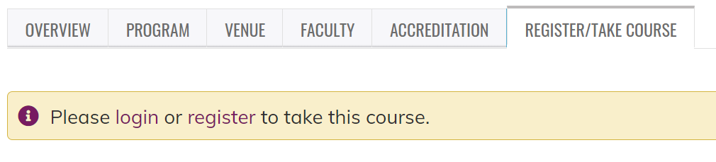

- Follow the steps to create an account (or log in if you already have an account). Be sure to:
  - Use an email you access regularly;
  - List your degree (If you are a Pharm Tech, be sure to click that for degree);
  - Enter your NABP Number in the Business ID (Pharmacists only); and
  - Enter your DOB (only MMDD).

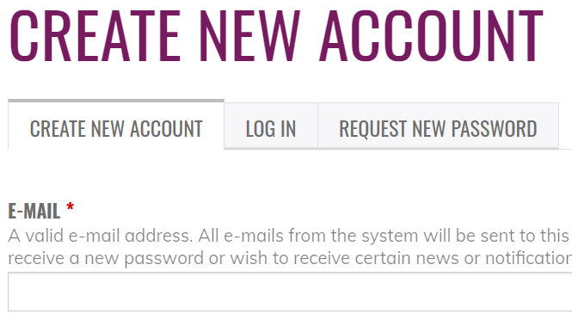

- You will then be able to find the program in your pending activities.
  - Click “My Account” at the top of the page and select “My Courses” from the drop-down list:

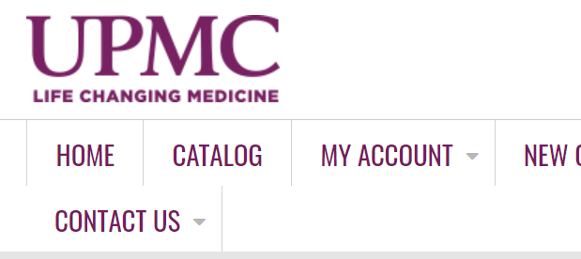

  - Click on “My Activities” and select “Pending Activities” (if the course does not display, you may need to log out or click the registration link again and select “Register”):

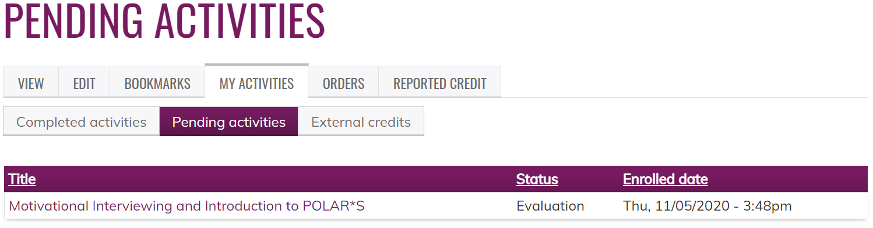
Registration questions? Contact Dan.Lomauro@pitt.edu.

