Announcing the launch of the Institute for Clinical Research Education’s
MedEd Mini-Course Program!

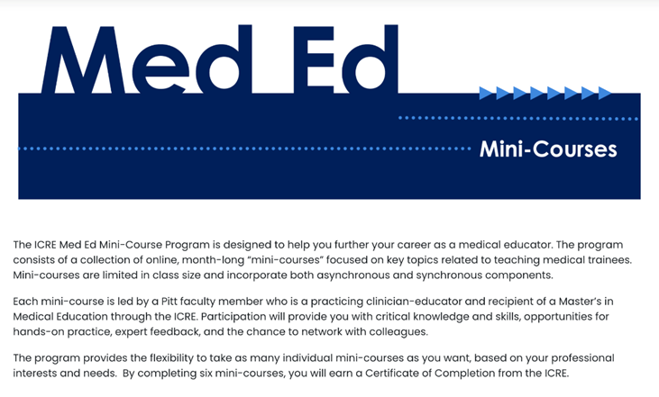

This exciting new program features 4-week, small-enrollment, online “mini-courses” focused on timely topics in medical education. Participants will gain critical knowledge and skills, hands-on practice, expert feedback, and the opportunity to network with colleagues.

Learners: This program is designed for health professions educators looking to expand and refine their teaching skills.

Instructors: Each mini-course is led by a Pitt faculty member who is a practicing clinician-educator with a Master’s in Medical Education from the ICRE.

Format: Courses are fully online, incorporating both asynchronous and synchronous components, and will be highly interactive and focused on practical skill-building.

Commitment: Each course requires 2 hrs/week of asynchronous and 2 hrs/week of synchronous work. Participants should plan to be actively engaged.

Cost: Tuition for each course is $400.

Credentialing: Take as many courses as you like, based on your professional interests and needs! Each completed course confers CME credit, with six completed courses conferring a Certificate of Completion from the ICRE.

Courses

Effective Feedback (Instructor: Dr. Sarah Merriam, MD)
In this course, we will introduce a feedback framework to categorize different forms of feedback, based on your goal. We will then explore how you, as a teacher, can optimize your feedback to maximize learner growth. We will also reflect on common affective challenges to giving (and receiving!) feedback. Synchronous online sessions Wednesday, 4:30-6:30 pm on 3/2, 3/9, 3/16, 3/23

