REGISTER NOW!

Overview of Medications for Opioid Use Disorder

April 8, 2022 12:00 – 1:00 PM

Register here: https://cce.upmc.com/content/overview-medications-opioid-use-disorder-moud-training-2022

This activity is approved for the following credit: AMA PRA Category 1 Credit™, ANCC, AAPA Category 1 CME, and ASWB.
Other health care professionals will receive a certificate of attendance confirming the number of contact hours
commensurate with the extent of participation in this activity.

Registration questions contact: Katie Wooten kew108@pitt.edu
COMPLETING COURSE REGISTRATION

- Open the registration link in your browser: https://cce.upmc.com/content/overview-medications-opioid-use-disorder-moud-training-peru-3421

- Click Register on the course page:

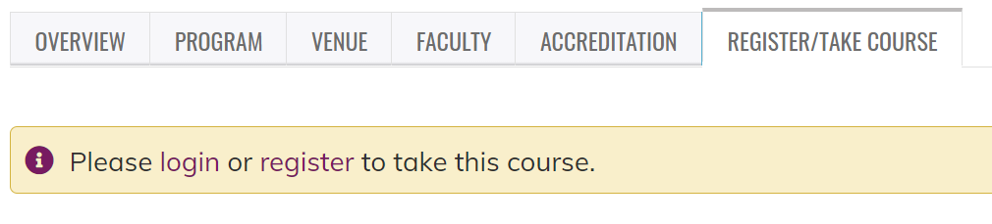

- Follow the steps to create an account (or log in if you already have an account). Be sure to:
  - Use an email you access regularly;
  - List your degree (If you are a Pharm Tech, be sure to click that for degree);
  - Enter your NABP Number in the Business ID (Pharmacists only); and
  - Enter your DOB (only MMDD).

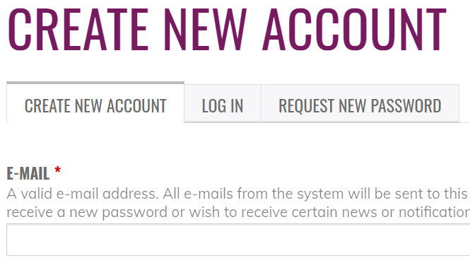

- You will then be able to find the program in your pending activities.
  - Click “My Account” at the top of the page and select “My Courses” from the drop-down list:

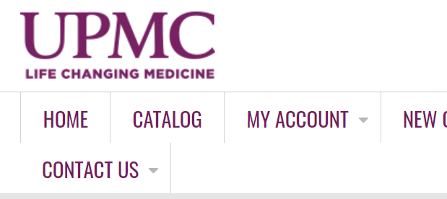

  - Click on “My Activities” and select “Pending Activities” (if the course does not display, you may need to log out or click the Overview of Medications for Opioid Use Disorder (MOUD) Training Peru 3.4.21 | UPMC - Center for Continuing Education in the Health Sciences again and select “Register”):

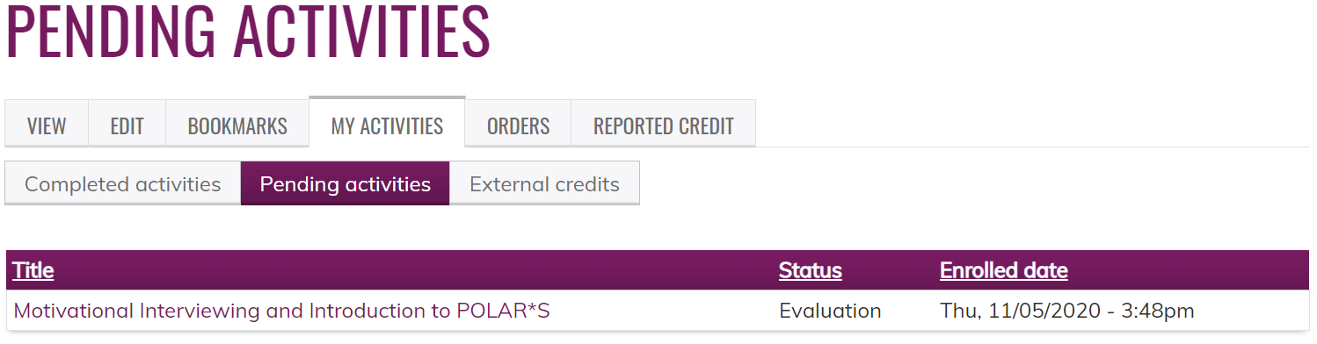
R
Registration questions? Contact Lori Abbott laa99@pitt.edu

