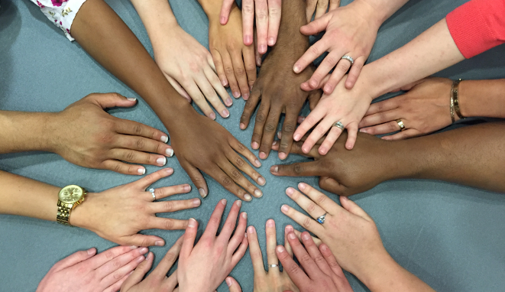

2nd Annual

Diversity, Equity, & Inclusion Symposium

Celebrating the Intersectionality of Diversity

Thursday, September 22nd, 2022
Virtual

PEDIATRIC GRAND ROUNDS
Challenges and Opportunities Facing Adolescent Health Perspectives from the Assistant Secretary for Health
8:00am – 9:00am
Presented by
Admiral Rachel Levine
Assistant Secretary for Health for the U.S. Health and Human Services, and the head of the U.S. Public Health Service Commissioned Corps.
Zoom link will be sent separately

SESSIONS

Asian Americans in Pittsburgh, from Exclusion to Inclusion
9:30am - 10:30am
Presented by
Marian Lien
Board president for OCA Asian Pacific American Advocates, Pittsburgh Chapter
Registration: https://pitt.zoom.us/webinar/register/WN_pZbWP0FbSyqHqddbkDF3KA
Minority Stress and Mental Health for LGBTQIA+ People
10:45am - 11:45am.
Presented by
Kristen Eckstrand, MD, PhD
Assistant Professor | Department of Psychiatry, University of Pittsburgh
Medical Director | UPMC LGBTQIA+ Health Quality
Registration: https://pitt.zoom.us/webinar/register/WN_zsqwOHtDT1GuYj2WEZu71g

Book Club Forum: “Racism, Not Race”
12:00pm – 1:00pm
With perspective on tactics and strategies by
Joseph Wright, MD, MPH
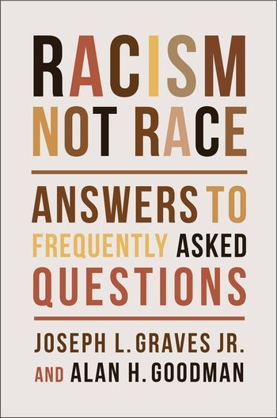

First 30 to register will receive a free book in your choice of hardback or kindle.
Registration: https://pitt.zoom.us/meeting/register/tJwscuutqDwvGt3rft8xee82l6tQPhYM8-o3

Please join us for discussion whether you have time to read the book or not. If time allows for targeted
reading, consider the Introduction and chapters 1, 4 and 6. Registration link provides full details.

Sponsored By Contact

The Office of Diversity, Equity, and Inclusion Loreta Matheo: loreta.matheo@chp.edu
and Noel Spears: zuckns@chp.edu
The Office of Education Jess Hammill: hammillj2@upmc.edu
Department of Pediatrics, University of Pittsburgh Savannah Rider: riders@upmc.edu

This activity is approved for the following credit: AMA PRA Category 1 Credit™

