HOW TO CLAIM YOUR CREDITS

CME CREDITS
The University of Pittsburgh School of Medicine designates this live activity for a maximum of
11.25 AMA PRA Category 1 Credits™. Other health care professionals will receive a certificate of attendance confirming the number of contact hours commensurate with the extent of their participation in this activity.

Complete before NOVEMBER 29, 2022

How to receive your credit and certificate

- Go to http://cce.upmc.com/code
- *Login to your account. * If you are a new user, create an account.
- Submit attendance code QEVBEV

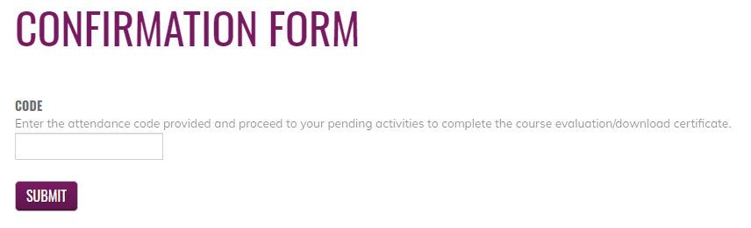

- Go to My Account, My Activities, Choose Pending Activities.
- Click on the course title to complete the course evaluation.
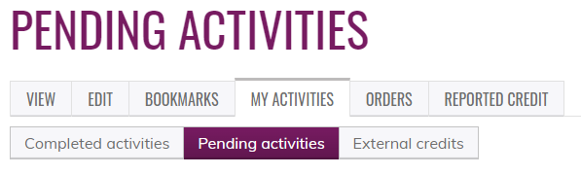

Certificates will be available to download and stored for future reference.

