**Motivational Interviewing and POLAR*S Training**



**March 9, 2023, from 1:00 PM – 3:00 PM.**

**By the end of the training participants will be able to:**

* Define **motivational interviewing** (MI) and demonstrate the **spirit of MI**.
* Differentiate between the **stages of change** and identify which stage your patients may be in.
* Use the **POLAR*S framework** to conduct an intervention to learn more about a patient’s drug and/or alcohol use and facilitate behavior change.

**Click here to** [**register now**](https://cce.upmc.com/content/introduction-motivational-interviewing-and-polars-training-peru-3923)

**Accreditation and Credit Designation**

In support of improving patient care, the University of Pittsburgh is jointly accredited by the Accreditation Council for Continuing Medical Education (ACCME), the Accreditation Council for Pharmacy Education (ACPE), and the American Nurses Credentialing Center (ANCC), to provide continuing education for the healthcare team.

Physician (CME) The University of Pittsburgh School designates this live activity for a maximum of 2.0 AMA PRA Category 1 Credits™. Physicians should claim only the credit commensurate with the extent of their participation in the activity.

Nursing (CNE) The maximum number of hours awarded for this Continuing Nursing Education activity is 2.0 contact hours.

Social Work (ASWB) As a Jointly Accredited Organization, University of Pittsburgh is approved to offer social work continuing education by the Association of Social Work Boards (ASWB) Approved Continuing Education (ACE) program. Organizations, not individual courses, are approved under this program. State and provincial regulatory boards have the final authority to determine whether an individual course may be accepted for continuing education credit. University of Pittsburgh maintains responsibility for this course. Social workers completing this course receive 2.0 continuing education credits.

Physician Assistant (AAPA) The University of Pittsburgh has been authorized by the American Academy of PAs (AAPA) to award AAPA Category 1 CME credit for activities planned in accordance with AAPA CME Criteria. This activity is designated for 2.0 AAPA Category 1 CME credits. PAs should only claim credit commensurate with the extent of their participation.

Other Healthcare Professionals Other health care professionals will receive a certificate of attendance confirming the number of contact hours commensurate with the extent of participation in this activity.

**COMPLETING COURSE REGISTRATION**

1. Open the registration link in your browser

* [https://cce.upmc.com/content/introduction-motivational-interviewing-and-polars-training-peru-3923](https://nam12.safelinks.protection.outlook.com/?url=https%3A%2F%2Fcce.upmc.com%2Fcontent%2Fintroduction-motivational-interviewing-and-polars-training-peru-3923&data=05%7C01%7CLAA99%40pitt.edu%7C2c27558747b04e081bc208dafe456ffa%7C9ef9f489e0a04eeb87cc3a526112fd0d%7C1%7C0%7C638101871427101684%7CUnknown%7CTWFpbGZsb3d8eyJWIjoiMC4wLjAwMDAiLCJQIjoiV2luMzIiLCJBTiI6Ik1haWwiLCJXVCI6Mn0%3D%7C3000%7C%7C%7C&sdata=mqjE91OnVDNiRd9E%2FMdPejjTnUG7gElY6HVVB4sfZe0%3D&reserved=0)

1. Click **Register/Take Course** on the course page

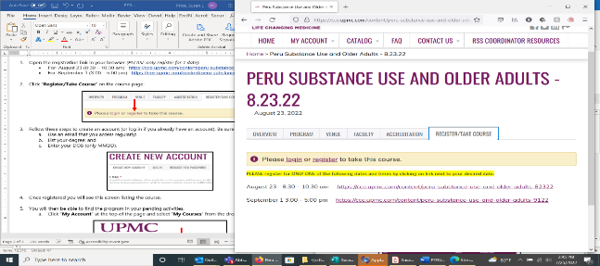

1. To create an account, follow these steps *(or log in if you already have an account)*. Be sure to:
   1. Use an email that you access regularly;
   2. List your degree; and
   3. Enter your DOB (only MMDD).

1. Once registered, you will see this screen listing the course:

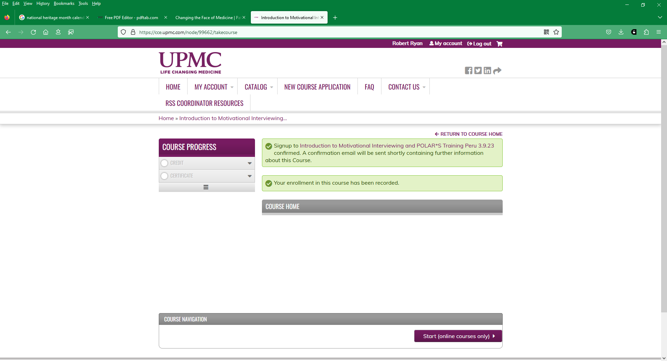

1. You will then be able to find the program in your pending activities.
   1. Click **My Account** at the top of the page and select **My Activities** from the drop-down list:

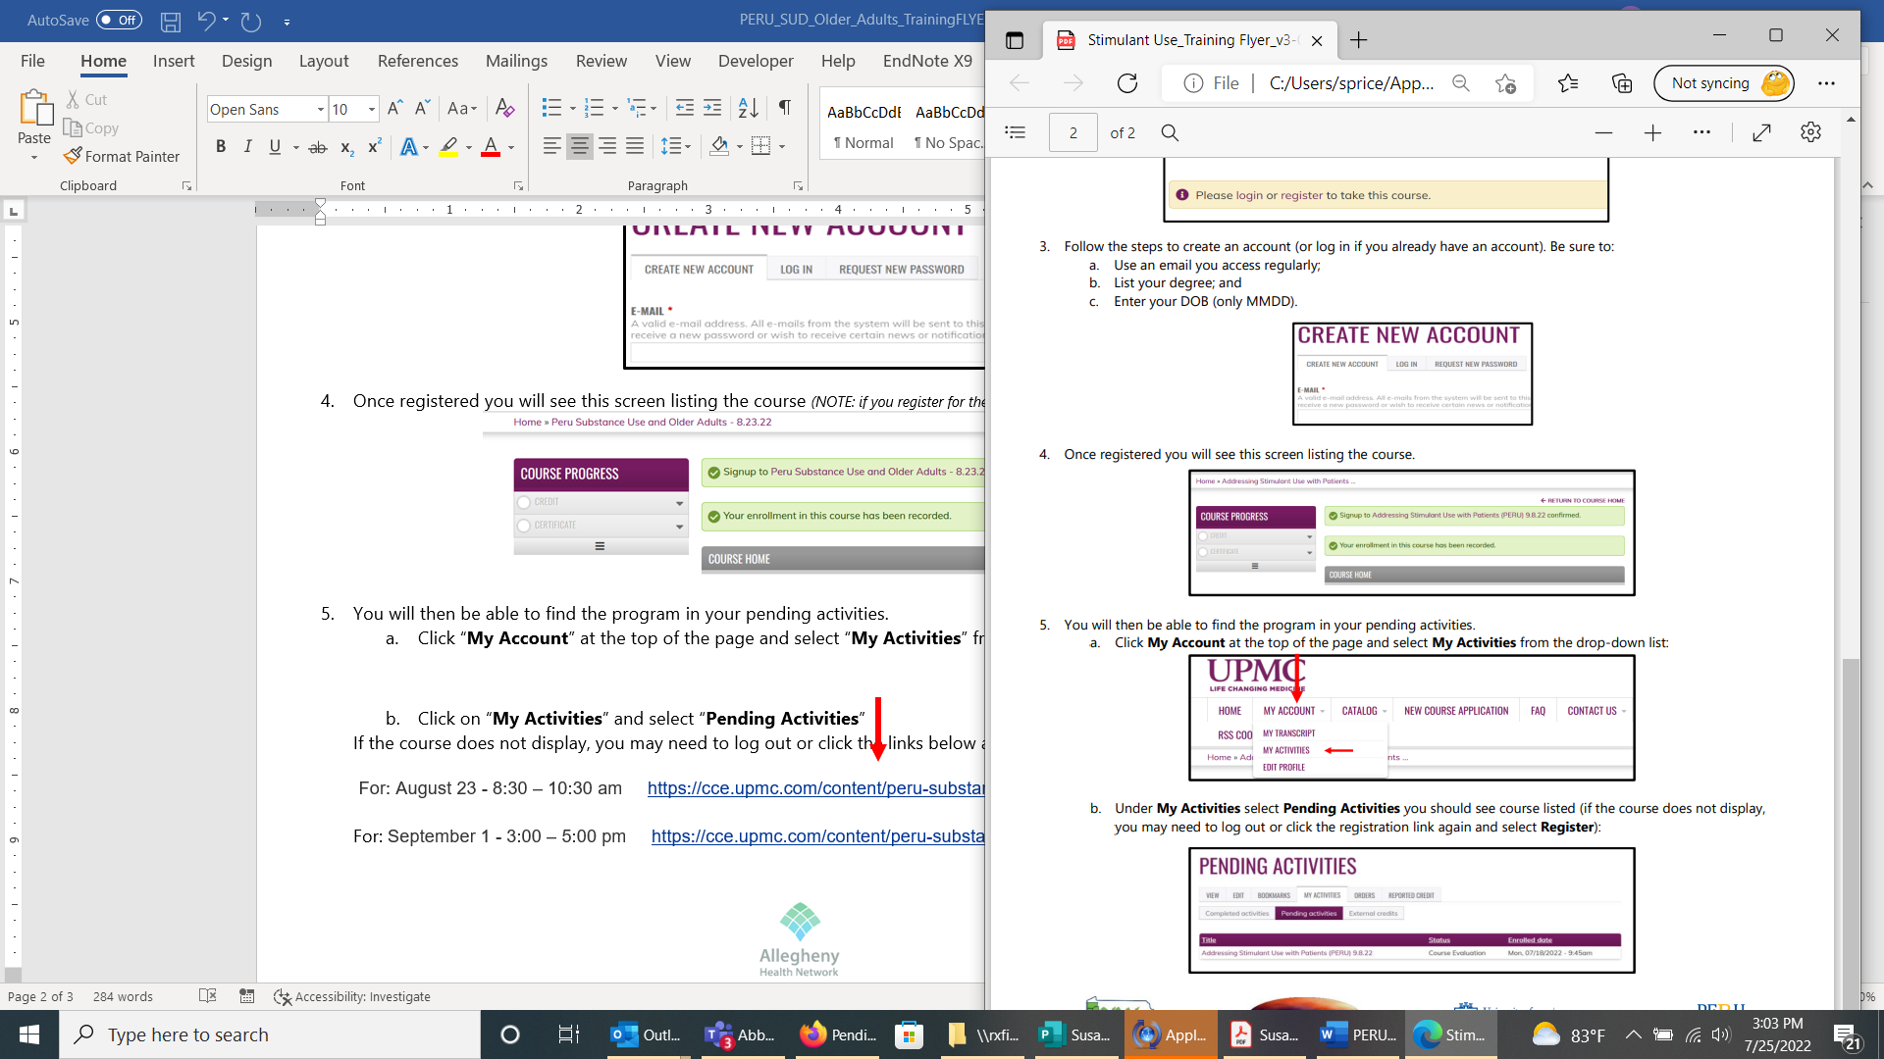

* 1. Under **My Activities** and select **Pending Activities,** you should see the course listed (if the course does not display, you may need to log out or click the registration link again and select **Register**.

