HOW TO CLAIM YOUR CREDITS

Palliative Education & Training Day
(PET Day) - 4.18.28

Instructions:
How to receive your credit and certificate
Complete before April 28, 2023

- Go to http://cce.upmc.com/code
- *Login to your account. * If you are a new user, create an account.
- Submit attendance code: TOTGUR

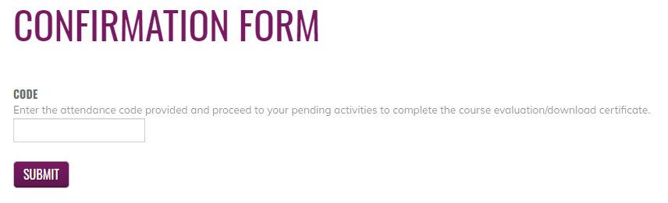

- Go to My Account, My Activities, Choose Pending Activities.
- Click on the course title to complete the course evaluation.
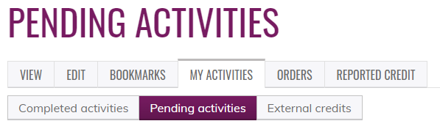

Certificates will be available to download and stored for future reference.

