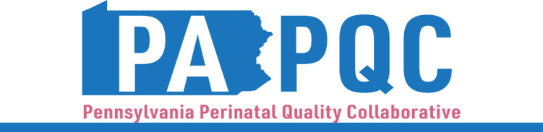

**PA PQC Northwest PA Regional Learning Session**

**Thursday, June 22, 2023**

**10:00 a.m. to 12:00 p.m. ET**

**Virtual**

Register: <https://us06web.zoom.us/meeting/register/tZUufu2pqjsrGNAlJEIUL5unzQhuEXAPtjPi#/registration>

*This session applies to organizations in Cameron, Clarion, Clearfield, Crawford, Elk, Erie, Forest, Jefferson, McKean, Mercer, Potter, Venango, or Warren County.*

**Learning Objectives:**

* Describe the current condition of maternal and neonatal care in Northwestern PA related to continuum of care needs
* Discuss regional resources and quality improvement opportunities for healthcare teams to engage with community organizations and agencies

**Agenda:**

10:00 am to 10:10 am – **Introduction: Regional Needs Related to NAS and Pregnancy-Associated Deaths, and Session Objectives** –Robert Ferguson, MPH, Chief Policy Officer, Jewish Healthcare Foundation (JHF

10:10 am to 10:40 am – **PA PQC** **Healthcare Teams: Quality Improvement Goals for 2023-2024** – Pauline Taylor, CQIA, Program Specialist, Jewish Healthcare Foundation

10:40 am to 11:00 am – **Spotlight on Northwest Community Activities**

11:00 am to 11:55 am – **Community Services and Supports** *– Pauline and Robert*

11:55 am to 12:00 pm – **Wrap-up & Next Steps –** Pauline