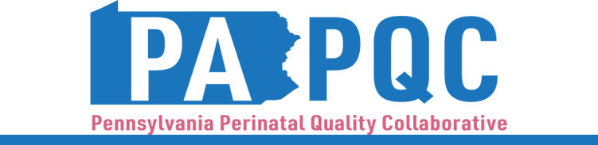

**PA PQC Southwest PA Regional Learning Session**

**Thursday, May 18, 2023**

**10:00 a.m. to 12:00 p.m. ET**

**Virtual**

*This session applies to organizations in Allegheny, Armstrong, Beaver, Bedford, Blair, Butler, Cambria, Fayette, Greene, Indiana, Lawrence, Somerset, Washington, or Westmoreland County.*

**Theme:** Continuum of care

**Learning Objectives:**

* Describe the current condition of maternal and neonatal care in Southwestern PA related to continuum of care needs
* Discuss regional resources and quality improvement opportunities for healthcare teams to engage with community organizations and agencies

**Agenda:**

10:00 a.m. to 10:20 a.m. – **Welcome and Introductions, Goals and Objectives for the Session** –Robert Ferguson, MPH, Chief Policy Officer, Jewish Healthcare Foundation (JHF)

10:20 a.m. to 11:00 a.m. – **Panel: Bridging the Care Continuum** – Facilitated by Jennifer Condel

* + *Shawndel Laughner, St. Clair Hospital*
  + *Selena Eisenberg, Pittsburgh Birth Keeper*
  + *Lisa Pareso, Washington Health System*

11:00 a.m. to 11:55 a.m. – **Breakout Rooms: Quality Improvement Opportunities** –

* + *Community based orgs- segments (prenatal, postpartum- SDoH]*
  + *Single County Authority- drug and alcohol*
  + *Children and family agencies- early intervention*
  + *Center of Excellence- OUD (certified recovery specialists)*

11:55 am to 12:00 pm – **Wrap-up & Next Steps –** Sara Nelis, RN, PA PQC Project Manager, Jewish Healthcare Foundation