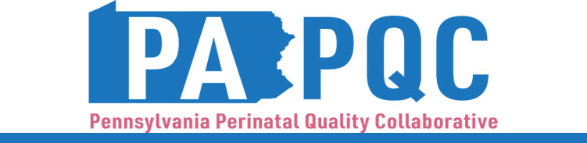

**PA PQC Northwest PA Regional Learning Session**

**Thursday, June 22, 2023**

**10:00 a.m. to 12:00 p.m. ET**

**Zoom**

*This session applies to organizations in Cameron, Clarion, Clearfield, Crawford, Elk, Erie, Forest, Jefferson, McKean, Mercer, Potter, Venango, or Warren County.*

**Learning Objectives:**

* Describe the current condition of maternal and neonatal care in Northwestern PA related to continuum of care needs
* Discuss regional resources and quality improvement opportunities for healthcare teams to engage with community organizations and agencies

**Agenda:**

1. **Introduction: Regional Needs Related to NAS and Pregnancy-Associated Deaths, and Session Objectives** –Robert Ferguson, MPH, Chief Policy Officer, Jewish Healthcare Foundation

2. **PA PQC** **Healthcare Teams: Quality Improvement Goals for 2023-2024** – Pauline Taylor, CQIA, Program Specialist, Jewish Healthcare Foundation

* *When thinking about the physical, mental, and social health needs of the pregnant/postpartum individuals with substance use you care for, what goals is your PA PQC Healthcare Team prioritizing for the April through March Implementation Period?*
* *To inform your work on these goals, what would you like to know from the community partners?*

3. ***Panel*: Spotlight on Northwest Community Activities** – Facilitated by Pauline Taylor, CQIA

*Lisa Herrmann Bradley, Program Director, Gaudenzia*

*Erika Pluta, MSW, Social Worker, Saint Vincent Hospital, AHN*

4. ***Discussion*: Community Services and Supports** *–* Co-facilitated by Jennifer Condel, SCT(ASCP)MT, Lean Healthcare Manager, Jewish Healthcare Foundation and Robert Ferguson, MPH

* *What guidance do you have for the PA PQC Healthcare Teams?*
* *Based on the needs of pregnant/postpartum individuals, what processes have worked well to engage individuals in your services?*

5. **Wrap-up & Next Steps** – Pauline Taylor, CQIA