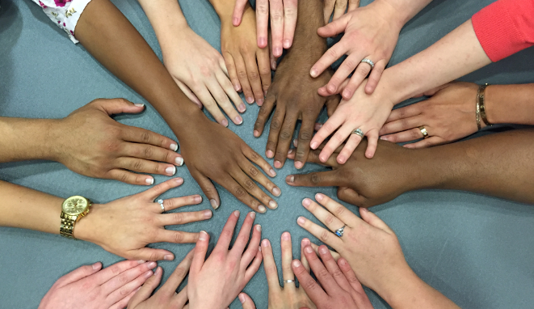
3rd Annual

Diversity, Equity, & Inclusion Symposium

The Intersections of Religion, Spirituality,
and Medicine

Thursday, September 14th, 2023
8am – 1pm
Hybrid

PEDIATRIC GRAND ROUNDS
Title of didactic
8:00am – 9:15am
Presented by
Dr. Aasim Padela
about info
Zoom link will be sent separately

SESSIONS
Spirituality, Health, and the Wellness of
Black Minds, Bodies, and Souls
9:30am - 10:30am
Presented by
Dr. Stephanie Boddie
Associate Professor of Church and Community Ministries
Baylor University
Registration: link here
Righteousness, Risk, and Repentance: Jewish Responses for When Bad Things Happen to ‘Good’ Patients
11:00am - 11:45am.
Presented by
Jonathan Weinkle, MD, FAAP, FACP
about info
Registration: zoom link here

Panel Discussion
Living With One’s Faith in the Medical Space

12:00pm – 1:00pm
Presented by
Janet Digber-Williams MD Danyah Hasan, MS, CCLS
Andrew McCormick, MD, FAAP Tahniat Syed, MD MPH
Rameshwari Tumuluru, MD Michael Moritz, MD
Rachel Kranson, PhD Benjamin Gordon, PhD
Aaron Brenner

About info
Registration: zoom link

Sponsored By

CHP / University of Pittsburgh
Department of Pediatrics
The Office of Diversity, Equity, and Inclusion
The Office of Education

Contact

Loreta Matheo: loreta.matheo@chp.edu
Noel Spears: spearsnb@upmc.edu
Jess Hammill: hammillj2@upmc.edu
Savannah Rider: riders@upmc.edu

“This activity is approved for the following credit: AMA PRA Category 1 Credit™, ANCC, ASWB, and AAPA Category 1 CME. Other health care professionals will receive a certificate of attendance confirming the number of contact hours commensurate with the extent of participation in this activity.”

