**REGISTER NOW!**



**Attitudes and Perceptions of**

**Substance Use Disorder**

**September 29, 2023 12:00 PM – 1:00 PM**

**Family Medical Center; 1086 Franklin St; Johnstown, PA 15905; Ground Floor**

**Register here:** **insert link**

This activity is approved for the following credit:  *AMA PRA Category 1 Credit™*, ANCC, AAPA Category 1 CME, and ASWB.

Other health care professionals will receive a certificate of attendance confirming the number of contact hours

commensurate with the extent of participation in this activity.

**COMPLETING COURSE REGISTRATION**

1. Open the registration link in your browser:

{insert link}

1. Click “**Register/Take Course**” on the course page:

1. Follow these steps to create an account (or log in if you already have an account). Be sure to:
   1. Use an email that you access regularly;
   2. List your degree (If you are a Pharm Tech, be sure to click that for degree);
   3. Enter your NABP Number in the Business ID (Pharmacists only); and
   4. Enter your DOB (only MMDD).

1. You will then be able to find the program in your pending activities.
   1. Click “**My Account**” at the top of the page and select “**My Courses**” from the drop-down list:

* 1. Click on “**My Activities**” and select “**Pending Activities**”
     1. If the course does not display, you may need to log out or click the {insert link}again and select “**Register**”:

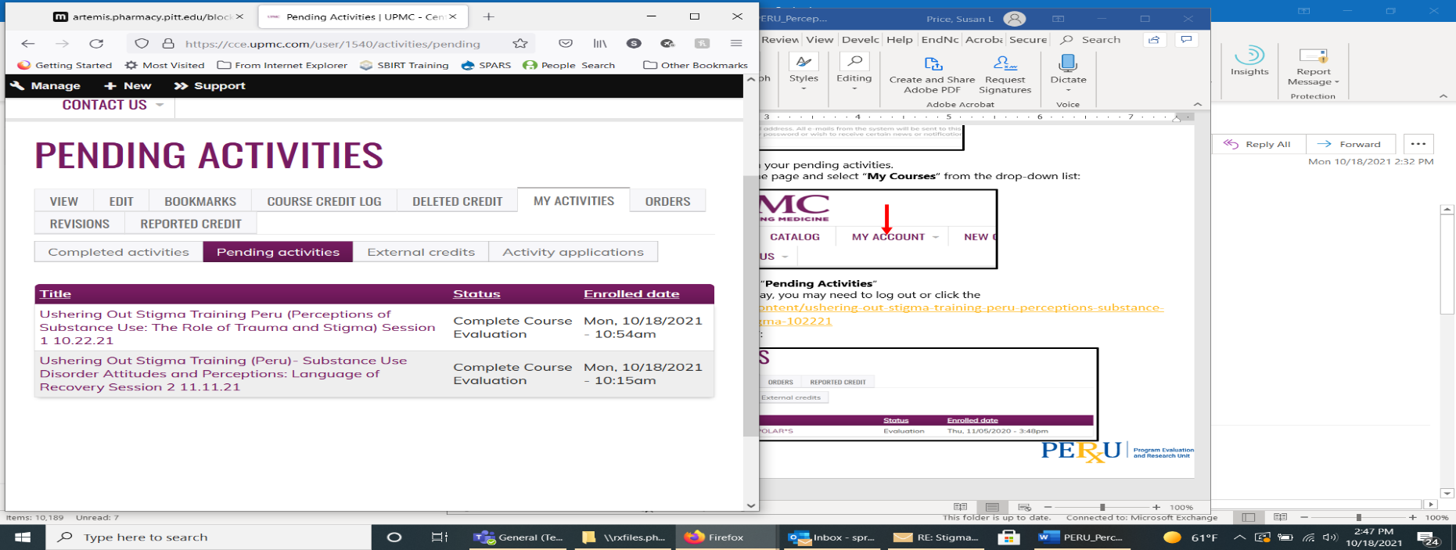

Registration questions? Contact Lori Abbott laa99@pitt.edu