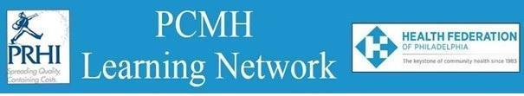

**HealthChoices PCMH Learning Network**

**Northeastern PA**

**Register**[**here.**](https://us06web.zoom.us/meeting/register/tZIldu2rrj4iHdbdB9t9jH242_MmTUJXuz-u#/registration)

**Learning Objectives:**

* Identify approaches for providing patients with fluoride varnish in primary care.
* Discuss ways to access oral health services for your patients.
* Describe examples of how PCMHs currently provide preventive dental health services and referrals.

**Agenda:**

8:30 a.m. to 8:45 a.m. – **Welcome** – Robert Ferguson, Chief Policy Officer, Pittsburgh Regional Health Initiative

8:45 a.m. to 9:00 a.m. – **Overview** – Shahram Shamloo, D.M.D., Chief Dental Officer, Commonwealth of Pennsylvania, Department of Human Services

9:00 a.m. to 10:00 a.m. – **Oral Health in Primary Care** – Helen Hawkey, Executive Director, Pennsylvania Coalition for Oral Health

10:00 a.m. to 10:25 a.m. – **PCMH Provider examples–** Facilitated by Pauline Taylor, CQIA, PRHI

* + Dan White, Public Health Hygienist, The Wright Center
  + Kimberly McGoff, Director of Dental Operations, The Wright Center

10:25 a.m. to 10:30 a.m. – **Wrap Up & Evaluation**