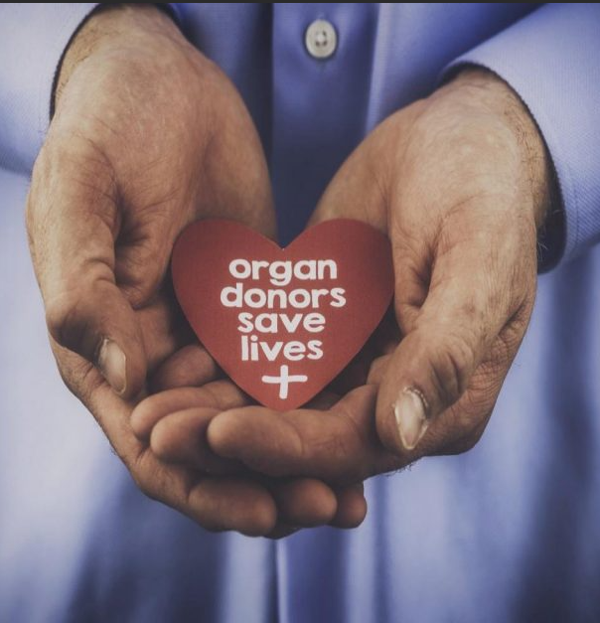  Gift of Life  - Trauma Course  This course is designed to aid staff in effective communication between all on the health care team, including the Transplant coordinators, related to timely referrals of donors and the care of patients through brain death and DCD.  Register by November 9th  https://cce.upmc.com/gift-life-trauma-course-november-2023  Registration is not mandatory but strongly encouraged  Questions & additional information: Heidi Weeder- Weederhn@upmc.edu | ELM Conference Room,  November 16, 2023  8am- 10:30am  o  UPMC Williamsport  Speakers:  Christina Sarge  GOL Hospital Services Coordinator, Philadelphia, PA  Michael Pearl, PA-C  Acute Care/Trauma, UPMC Williamsport, PA  Marie Magyar  GOL Transplant Coordinator, Philadelphia, PA  2.5 RN Contact Hours  American Nurses Credentialing Center (ANCC)  UPMC Trauma Credit Approved
Gift of Life Trauma Course
Conference Room
November 16, 2023 8:00am

Activity Agenda

- 8:00am – Welcome & Introductions
Heidi Weeder RN, ICU Senior Clinician,
UPMC Williamsport, Williamsport, PA

- 8:05am – Connect to Purpose

- 8:15am - Collaborating for Life: The Donation Process
Christina Sarge, Hospital Services Coordinator,
Gift of Life Donor Program, Philadelphia, PA

- 8:55am – Determination of Brain Death
Michael Pearl PA-C, Acute Care/Trauma,
UPMC Williamsport, Williamsport, PA

- 9:35am – Clinical Evaluation & Management of the Potential Organ Donation
Marie Magyor RN, CPTC, Transplant Coordinator,
Gift of Life Donor Program, Philadelphia, PA

- 10:15am – Open Discussion

- 10:30am – Closing and Survey

*Times subject to modification based on questions and discussion

