PA Chapter American Academy of Pediatrics
Guiding Them Home Safely: Child Passenger Safety (CPS) for Health Care Providers
Date: Wed, Nov 8, 2023
Time: 12:00 pm – 1:00 pm
UPMC Harrisburg
Harrisburg, PA

This activity is approved for the following credit: ANCC and AMA PRA Category 1 Credit™. Other health care professionals will receive a certificate of attendance confirming the number of contact hours commensurate with the extent of participation in this activity.

This is not your official certificate.

The UPMC Center for Continuing Education in the Health Sciences (CCEHS) Continuing Education Learning Portal, https://cce.upmc.com, is used to claim and track your continuing education credits. Certificates will be available to download and stored for future reference.

To receive credit, login, complete the course evaluation and claim credit on the CCEHS Learning Portal, https://cce.upmc.com. The activity is accessible in your Pending Activities. Please allow up to 14 days before accessing.

If you are a new user, click Register (upper right corner) to create an account. The email address used to register for this activity should be the same email you use when creating your account. If you choose a different email, please notify the UPMC Center for Continuing Education by emailing ccehs_support@upmc.edu or https://cce.upmc.com/contact-us to update your attendance records.

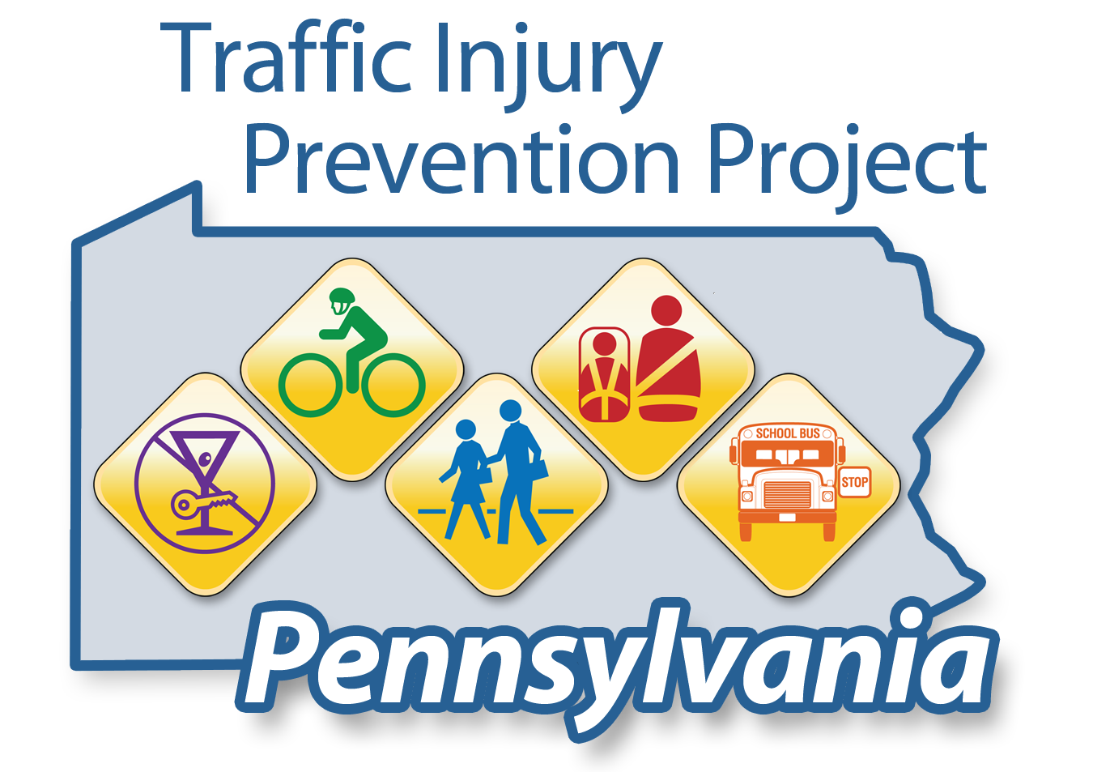
To answer common questions or for step by step instructions please visit the FAQs available on the CCEHS Learning Portal.

Kelly Whitaker, Central Regional Training Coordinator
Email: kwhitaker@paaap.org
Phone: 814-943-3360

