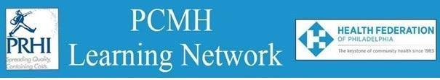

**HealthChoices PCMH Learning Network**

**Western PA**

**November 30, 2023**

**Learning Objectives:**

* Identify approaches for providing patients with fluoride varnish in primary care.
* Discuss ways to access oral health services for your patients.
* Describe examples of how PCMHs currently provide preventive dental health services and referrals.

**Agenda:**

8:30 a.m. to 8:40 a.m. – **Welcome** – Robert Ferguson, Chief Policy Officer, Pittsburgh Regional Health Initiative

8:40 a.m. to 9:00 a.m. – **Reflections and Next Steps from the Statewide Health Equity PCMH Learning Network Session**– Facilitated by Jennifer Condel, SCT(ASCP)MT, Manager, Lean Healthcare Strategy and Implementation, Pittsburgh Regional Health Initiative

* Kristin Lazzara, MBA, MHA, AHN Center for Inclusion Health
* Pamela L. Hess, BA RN CRRN CCM, Telephonic Care Manager, UPMC Community Medicine Inc.

9:00 a.m. to 9:10 a.m. – **Introductory Remarks on Dental Health** – Shahram Shamloo, D.M.D., Chief Dental Officer, Commonwealth of Pennsylvania, Department of Human Services

9:10 a.m. to 10:10 a.m. – **Oral Health Roles and Resources for Primary Care Settings** – Helen Hawkey, Executive Director, Pennsylvania Coalition for Oral Health

10:10 a.m. to 10:25 a.m. – **Examples of How PCMHs have Operationalized Oral Health Practices** Facilitated by Pauline Taylor, CQIA, PRHI

* Leslie Aleck, RN, Clinical Nurse Manager Asst, UPMC Children’s Community Practice

10:25 a.m. to 10:30 a.m. – **Wrap Up & Evaluation**