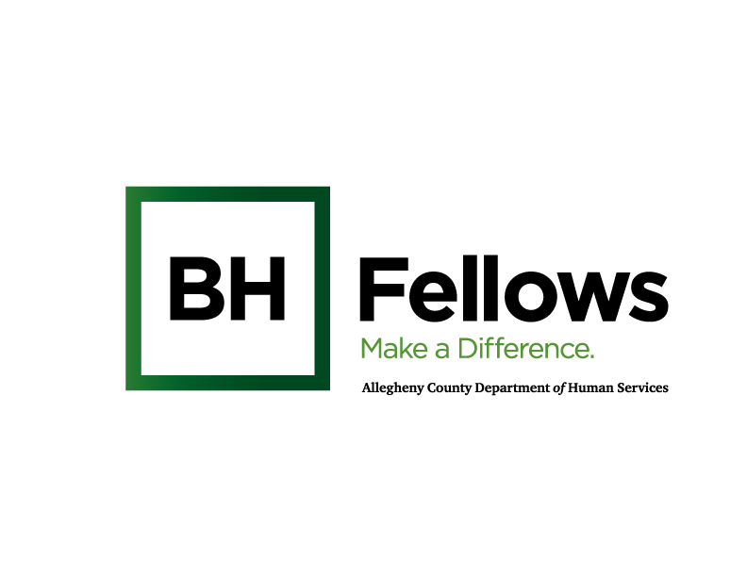
DRAFT

Cohort 1: Pathfinders
November 9, 2023
9:00am – 12:00pm

Virtual Zoom: https://us06web.zoom.us/j/89149423773?pwd=VPOkHWwy7a8IBY6aMlGBoDzgSxd5tO.1
Meeting ID: 891 4942 3773
Passcode: 431910

SW Credit Course Title: Harm Reduction: Working with Clients and their Support System
No. of credit hours: 1.5 for SW
Time | Component | Content | Presenter/Facilitator
8:30 AM | Check-in | Open Zoom Meeting | -Jess: make staff co-hosts, hit record, spotlight speaker(s)  -Scotland: screenshots  -Jen: monitor chat, run breakouts
8:50 AM |  | Tech check with Alice Bell | Jen to run slides
9:05 AM | Welcome & Introductions | Open with Grounding Exercise  - 5-4-3-2-1  - Chat: Feelings check in - How are you feeling today? What do you need from the group or someone in the room?  Reflections  - What has been your experience returning to your workplace after the October session?  - Have you been able to apply lessons from the discussions on Ethics or applied what you heard into your work?  Introduce Alice Bell | Jessica Segal, LCSW  Behavioral Health Program Associate  Bridget McNamee, MID, Behavioral Health Project Manager, Jewish Healthcare Foundation
9:30 AM | Harm Reduction | Harm Reduction Overview and Community Examples.  - Describe harm reduction philosophy and how it differs from traditional models.  - Attendees will be able to examine how harm reduction could be implemented in various contexts  - Attendees will develop models for how the role of family members, friends, and community resources can integrate with a harm reduction model.  Community Spotlight: Prevention Point Pittsburgh  - Services and programs offered  - Referral process | Alice Bell, LCSW  Overdose Prevention Project Director, Prevention Point Pittsburgh
10:15 AM | Break | 10 min Break
10:25 AM | Debrief | Questions and Answers: Harm Reduction  - Fellow debrief with Alice regarding content and context | Alice Bell
10:35AM | Breakout Groups | Applying Harm Reduction Approaches  - Small group discussions  - Micro level: how can you (or do you) implement harm reduction practices into your work?  - Meso level: how can you (or do you) support clients and families in practicing harm reduction approaches?  - Macro level: how can you support organization-wide implementation of harm reduction approaches at your organization?  - Do you have harm reduction focused policies? | Alice Bell  JHF Staff
11:05 AM | Large Group | Applying Harm Reduction Approaches: Debrief  - Each breakout group reports on the questions  - Large group discussion | Alice  JHF Staff
11:35 AM | Information Gathering | Survey Activity  Help us think through how we can best create future sessions for you.  Scotland: QR code for survey + link in the chat | Bridget
11:45 AM | Wrap-up and Reminders | Reflections and Take-aways:  - Aha’s from the session  - Reflection Questions (How support one another over the course of the cohort?)  - Next session: Thursday, December 7th, 9:00 am- 12:00 pm, in-person  - CEU Survey Deadline: December 14th  4 question survey at end of session  *CEU email: Jen send November 10th | Bridget
11:45 AM | Self-care | Identify and Practice a Self-care Activity | Fellows
12:00 PM | Departure

