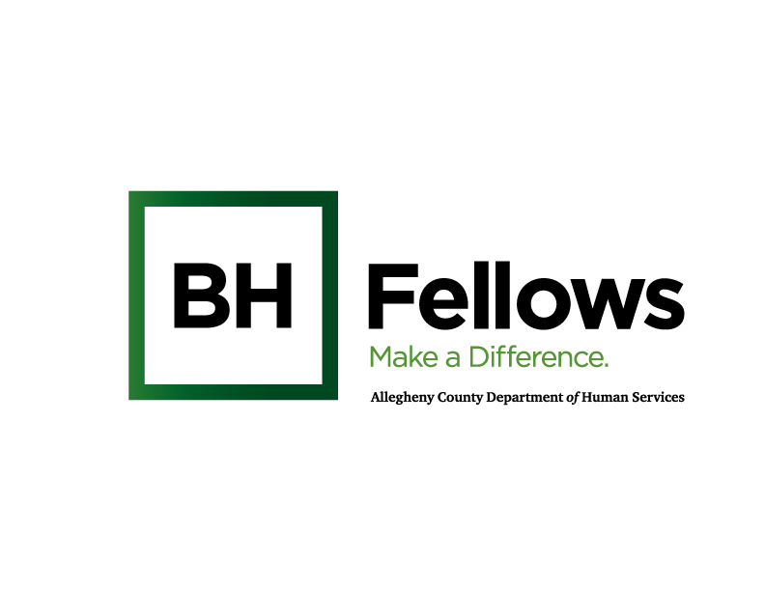
Drum circle on 2nd Floor
Annotated Agenda/ Working Draft
12.18.23

BH Hellos (Cohort 2)
January 18, 2024
9:00am – 5:00pm

JHF Offices| EQT Plaza, 625 Liberty Ave, Ste. 2500, Pittsburgh, PA 15222

SW CEU Credit Course Title: Cultural Humility in Behavioral Health
Requested SW CEU Credits: 3.25 hrs
Application Due: Dec. 18

Prework: Share on THC what populations they work with and post videos to view to prime for discussions (Carol)

Time | Component | Content | Presenter/Facilitator
8:30 AM | Check-in | Light breakfast refreshments | Bridget C
9:05 AM | Welcome & Introductions  *remind of parking lot | Open with Sanctuary Model (slide)  - How are you feeling today?  - What do you need from the group or someone in the room?  - What will you bring to the group?  Intro: name, role, org  Share: an example of a valuable cultural humility training or area of interest related to cultural humility  Reflections  - What has been your experience returning to your workplace after the December session?  - Have you been able to apply lessons from discussions during our last session? | Jessica Segal, LCSW  Behavioral Health Program Associate  Jewish Healthcare Foundation  Bridget McNamee, MID, Behavioral Health Project Manager, Jewish Healthcare Foundation
9:35 AM | Group Intention Setting  [1.5hrs CEUs] | Setting the Stage to Discuss Cultural Humility  - Define Cultural Humility and application in behavioral health.  Group Discussion:  - Set intentions as a large group.  - The session is not intended to fully cover this topic; give insight to various populations across the Pittsburgh region.  - What would the group like to explore in future sessions?  - Utilize parking lot to record areas of interest. | Rachel Vinciguerra  Director of National Programs,  Hello Neighbor  (confirmed, need COI)
11:00 AM | Break
11:15 AM |  | BH Fellow Spotlight | TBD
11:45-12:45 | Lunch
12:45 PM | Resources and Application  [1.25 hrs CEU] | Panel Discussion: Community Organizations Serving Allegheny County  Questions:  - How can fellows make connections between their clients and these organizations? | Coley Alston, MPH  Program Director,  Hugh Lane Wellness Foundation  (in process of confirming)  Courtney Abegunde-  Program Manager of Implementation and Evaluation, Steel Smiling  (confirmed, waiting on COI)
2:00 PM  (0.5 CE hrs.) | Breakout Discussion: how apply what learned  [0.5hrs CEUs] | Small Group Discussion/Application  - What they heard in the morning.. – What are you processing? Did anything surprise you?  - What are your experiences working with people from different cultures?  - How can you as a leader use this information with your organization? | Small breakouts with Coley and Courtney
2:30 PM | Self-care Activity | TBD
3:05 PM |  | Break/transition to 2nd floor
3:30 PM | 2nd Floor | Drum Circle  3:30-4:30 pm | Music for Life of Pittsburgh, LLC  Stephanie and Robert Miller
4:30 PM | Wrap-up and Reminders | - Take aways.  - Reflection Questions (How to support one another over the course of the cohort?)  - Kudos and posting on Tomorrow’s Healthcare collaboration platform.  - Next session:  - Ask to take short survey at session: Scotland (QR code)
5:00 PM | Departure

