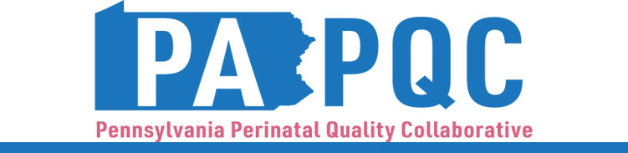

**PA PQC Virtual Learning Session**

**Thursday, March 21**

**11:00 a.m. to 12:00 p.m. ET**

**Virtual**

Zoom link will be sent to the email address you provided during registration

**Learning Objective:**

* Discuss team successes, challenges, and lessons learned during the 2023-24 Implementation Period in the Substance Use Disorder, Substance-Exposed Newborn, and IPLARC initiatives.

**Agenda:**

11:00 a.m. to 11:05 a.m. – **Welcome** –Sara Nelis, RN, Project Manager, Jewish Healthcare Foundation

11:05 a.m. to 11:15 a.m.– **Guthrie Robert Packer Hospital: Implementing Equity Pauses** –Jessica Miller, CNM

11:15 a.m. to 11:25 a.m.– **UPMC Northwest: Nurse Navigator for Patients with SUD** –Cheri Siverling, MSN, RNC-OB, Unit Director, UPMC Northwest & Kaleigh Gustafson, BSN, RNC-OB, Clinician, UPMC Northwest

11:25 a.m. to 11:35 a.m.– **Evangelical Community Hospital: Monthly SUD Committee & Prenatal Consults for ESC** –Jennifer Sullivan, BSN, RN, Maternal/Child Nurse Manager, Evangelical Community Hospital

11:35 a.m. to 11:45 a.m.– **Tower Health Phoenixville: Implementing IPLARC** –Tammy Renninger, BSN, RNC-OB, Clinical Coordinator, Women’s Health Pavilion, Phoenixville Hospital

11:45 a.m. to 11:55 a.m.– **Einstein Montgomery: SEN Education at Methadone Clinics and Family Health Centers** –Celina Migone, MD, Neonatologist, Einstein Montgomery Hospital & Amy L. Lembeck, DO, Neonatologist, Einstein Montgomery

11:55 a.m. to 12:00 p.m.– **Wrap-up & Next Steps –** Sara Nelis, RN