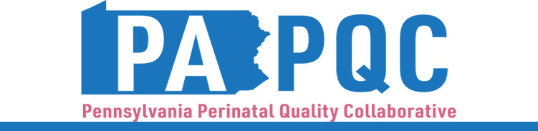

**PA PQC Virtual Learning Session**

**Wednesday, April 17**

**11:00 a.m. to 12:00 p.m. ET**

**Virtual**

Zoom link will be sent to the email address you provided during registration

**Learning Objective:**

* Describe a systematic approach to building quality improvement cycles for implementing PA PQC initiatives.
* Discuss approaches for managing quality improvement change in healthcare teams for PA PQC initiatives.

**Agenda:**

11:00 a.m. to 11:05 a.m. – **Welcome** –Sara Nelis, RN, Project Manager, Jewish Healthcare Foundation

11:05 a.m. to 11:45 a.m.– **Quality Improvement & Change Management** –Jennifer Condel, SCT(ASCP)MT, Manager of Lean Healthcare Strategy and Implementation, Jewish Healthcare Foundation

11:45 a.m. to 11:55 a.m.– **Q&A** –Facilitated by Jennifer Condel, SCT(ASCP)MT

11:55 a.m. to 12:00 p.m.– **Wrap-up & Next Steps –** Sara Nelis, RN