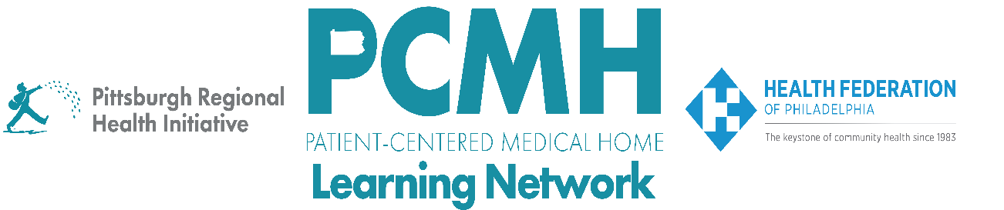

**HealthChoices PCMH Learning Network**

**Northeastern PA**

**May 21, 2024**

**Learning Objectives:**

* Describe what has worked well for PCMHs to recruit providers and staff.
* Describe workforce development programs and resources in the region.
* Describe best practices for retaining providers and staff.

**Agenda:**

8:30 a.m. to 8:35 a.m. – **Welcome** – Robert Ferguson, Chief Policy Officer, Pittsburgh Regional Health Initiative

8:35 a.m. to 9:15 a.m. – **Reflections and Report Outs**– Facilitated by Jennifer Condel, SCT(ASCP)MT, Manager, Lean Healthcare Strategy and Implementation, Pittsburgh Regional Health Initiative

**Reflection: Next Steps from the Statewide Hepatitis C PCMH Learning Network Session**

* What changes would you like to make to your Hepatitis C screening, testing, and treatment processes and workflows in response to the April 16 statewide learning session?

**Report Out: Workforce**

* Which roles have been hardest to fill?
* What training, recruitment, and retention~~s~~ strategies have you tried? What has worked well? What challenges are you facing?

9:15 a.m. to 9:50 a.m. – **Medical Assistant Externship**–Ali Murray, National Institute for Medical Assistant Advancement (NIMAA); The Wright Center, Kathleen Barry, Amber Bello, Nicole Munley, Graduate from Program – Melissa Lemus; Ali Murray, Director of Business and Partnership Development

9:50 a.m. to 10:00 a.m. – **BPHC Workforce Well-Being TA Center** – Michelle Vatalaro Dawson, MPH, Consultant, JSI Research & Training Institute, Inc. BPHC Workforce Well-Being TA Center

10:00 a.m. to 10:25 am – **Best Practices for Retention and Recruitment** – Stephanie J. Wroten RN, MSN, MS, LNC, Interim Chief Executive Officer & Chief Operations Officer, Roanoke Chowan Community Health Center

10:25 a.m. to 10:30 a.m. – **Wrap Up & Evaluation**

* Wrap Up Chat Question: Based on your context and what you heard today, what tactics will you be taking back to your team?