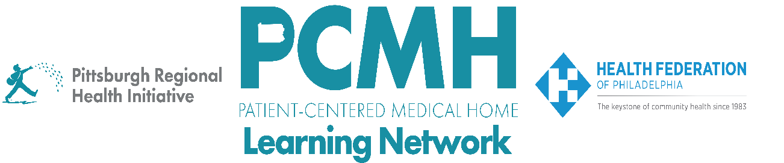

**HealthChoices PCMH Learning Network**

**Western PA**

**May 7, 2024**

**Learning Objectives:**

* Describe what has worked well for PCMHs to recruit providers and staff.
* Describe workforce development programs and resources in the region.
* Describe best practices for retaining providers and staff.

**Agenda:**

8:30 a.m. to 8:40 a.m. – **Welcome** – Robert Ferguson, Chief Policy Officer, Pittsburgh Regional Health Initiative

8:40 a.m. to 9:20 a.m. – **Reflections and Report Outs**– Facilitated by Jennifer Condel, SCT(ASCP)MT, Manager, Lean Healthcare Strategy and Implementation, Pittsburgh Regional Health Initiative

**Reflection: Next Steps from the Statewide Hepatitis C PCMH Learning Network Session**

* What changes would you like to make to your Hepatitis C screening, testing, and treatment processes and workflows in response to the April 16 statewide learning session?

**Report Out: Workforce**

* Which roles have been hardest to fill?
* What training, recruitment, and retention~~s~~ strategies have you tried? What has worked well? What challenges are you facing?

9:15 a.m. to 9:40 a.m. – **Medical Assistant Externship** – Cindy Reedy, BS RN, Executive Director of Training and Organizational Development, The Primary Health Network; Wanda Bauchman, Medical Assistant, The Primary Health Network

9:40 a.m. to 10:05 a.m. – **Healthcare Workforce Development Programs in Western PA** – Edgar Largaespada, Senior Director of Industry Strategy, Partner4Work

10:05 a.m. to 10:20 a.m. – **BPHC Workforce Well-Being TA Center** –Michelle Vatalaro Dawson, MPH, Consultant, JSI Research & Training Institute, Inc. BPHC Workforce Well-Being TA Center

10:20 a.m. to 10:30 a.m. – **Wrap Up & Evaluation**

* Chat Question: Based on your context and what you heard today, what tactics will you be taking back to your team?