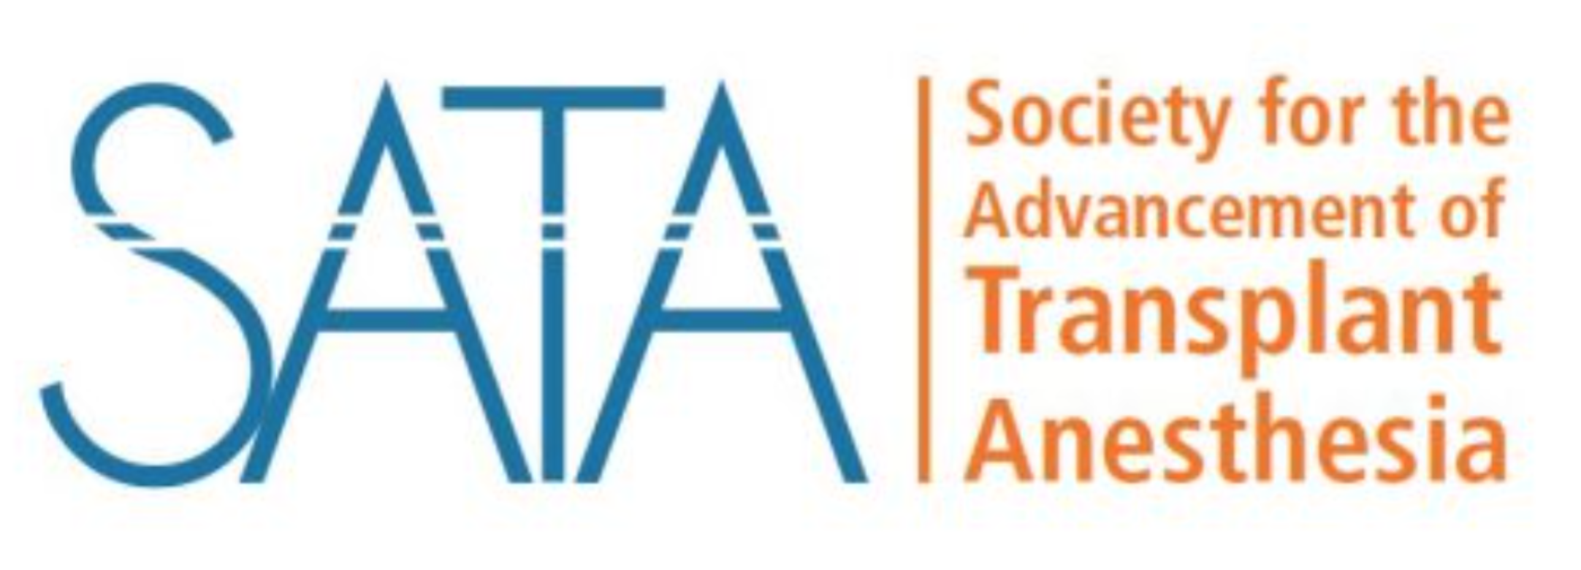
The 2024 Symposium of the Society for the
Advancement of Transplant Anesthesia (SATA)
In conjunction with the annual meeting of the International Anesthesia Research Society (IARS)
With interactive POCUS ultrasound and echocardiography training

Sunday May 19 to Monday May 20, 2024
Hyatt Regency Seattle Hotel, 5th floor, Room 502; 808 Howell St, Seattle, WA 98101
Registration (with CME credit): https://sata2022.wufoo.com/forms/mb1rdsj1psnxyg/
$50 for SATA, SOCCA and SCA members, $150 for non-members, free for trainees

Program overview:
This meeting is an in-person meeting designed to provide a multi-disciplinary review of the latest updates on a variety of preoperative, intraoperative, and postoperative critical care management topics for liver transplant patients.

Learning objectives:
- Understand Different Perspectives on Hemodynamic Monitoring during Liver Transplantation
- Evaluate the Safety of Red Blood Cell Transfusion in Transplantation
- Analyze Practice Patterns in Transplantation
- Debate the Perioperative Management of HOCM in Liver Transplant Candidate
- Assess Advanced Techniques in Thoracic Transplantation
- Examine Current Research in Transplant Anesthesiology
- Enhance Point-of-Care Ultrasound (POCUS) Skills for Transplant Anesthesiologists
- Analyze Clinical Cases in Transplant Anesthesia
- Evaluate the Impact of Machine Perfusion on Transplantation Practice

Target audience:
Transplant Anesthesiologists, Intensivists, Transplant Surgeons, Residents, Fellows, and Medical Students.

Accreditation and CME credit designation:
The Society for the Advancement of Transplant Anesthesia (SATA), University of Pittsburgh Medical Center

Program organizing institutions (Program committee members):
- The Society for the Advancement of Transplant Anesthesia (Gebhard Wagener, MD)
Platform: In person only

Sunday May 19, 2024
1:30 pm – 2:00 pm Registration
2:00 pm – 2:15 pm Welcome and Introduction
  - Gebhard Wagener, President SATA - Columbia University, New York, NY
2:15 pm – 3:15 pm: Session 1: International Session of the Korean Society of Transplantation Anesthesiologists (KSTA) and the Society for the Advancement of Transplant Anesthesia (SATA)
Moderators: Tetsuro Sakai - University of Pittsburgh Medical Center, Pittsburgh, PA
Lorenzo De Marchi - Georgetown University, Washington, DC
- Hemodynamic Monitoring during Liver Transplantation: A Korean perspectives
  - Sang-Hyun Kim - President KSTA, Soonchunhyang University, Republic of Korea
- Red blood cell transfusion in transplantation: Is it safe to use cell salvage in cancer patients?
  - Ji-Hye Kwon - Sungkyunkwan University, Republic of Korea
- A survey of practice patterns: Republic of Korea vs USA
  - Cara Crouch - University of Colorado, Aurora, CO
3:15 pm – 3:45 pm: Pro/Con debate: Perioperative management of HOCM in a liver transplant candidate: Pre-transplant myomectomy or ablation versus no intervention
Moderators: Ryan Chadha - Mayo Clinic Jacksonvile, FL
Uzung Yoon - Jefferson Health, Philadelphia, PA.
- No Intervention: Chris Racine – University of Alabama Medicine, Birmingham, AB
- Myomectomy or ablation: Selene Martinez Perez, Toronto General Hospital, Toronto, Canada
3:45 pm – 4:15 pm: Break
4:15 pm – 5:00 pm: Session 2: Thoracic transplant session
Moderator:
- Transesophageal Echocardiography for Heart and Lung Transplants
  - Sarah Cotter – Duke University, Durham, NC
- Enhanced Recovery after Surgery (ERAS) for heart and lung transplants
  - Kathir Subramaniam- University of Pittsburgh Medical Center, Pittsburgh, PA
- Combined Transplants: who is in charge, and why?
  - Yonggang Peng - University of Florida, Gainesville, FL
- Comparison among the cassette-based new point-of-care coagulation machines
  - Kenichi Tanaka - University of Oklahoma, Oklahoma City, OK
5:00 pm – 6:00 pm: Session 3: Research session
Moderator: Aliaksei Pustavoitau - Johns Hopkins University, Baltimore, MD
- SATA Transplant Anesthesia Databases
  - Heart: Joshua Knight- University of Pittsburgh Medical Center (UPMC)
  - Lung: Harikesh Subramanian - University of Pittsburgh Medical Center (UPMC)
  - Liver: Dieter Adelmann - University of California, San Francisco (UCSF)
- Annual SATA research prize
  - The winner of 2024 is…
  - Last year’s winner: Elizabeth Townsend - University of Wisconsin, Madison, WI
- What did we learn last year from the transplant anesthesiology literature?
  - Ryan Wang - Mount Sinai Medical Center, New York, NY

Monday May 20, 2024

8:00 am – 10:00 am: Point of Care Ultrasound (POCUS) Workshop for the Transplant Anesthesiologist
This workshop requires a separate registration with a maximum of 24 participants. Some POCUS TTE/TEE skills/experience to optimize workflow and learning experience are requested.
Cost: $25/ person; Register here: https://sata2022.wufoo.com/forms/mp82f2b1fh3gne/
For detail see next page

10:00 am – 10:30 am Break
10:30 am – 11:00 am: Case reports
Moderator: Nick Mendez - University of California, San Francisco (UCSF)
- Case 1: Pulmonary HTN and Severe AR during Liver Transplantation
  - Sarada Eleswarpu - Duke University, Durham, NC
- Case 2: Combined Liver lung transplant
  - George Zhou – Stanford Medicine, Stanford, CA
11:00 am – 12:00 pm: Session 4: Machine perfusion and donation: How does it affect my practice?
Moderator: Flora Simmons - University of Texas Southwestern Medical Center
- Machine Perfusion for Heart Transplants
  - Peter Neuberger - New York University, New York, NY
- Machine Perfusion for Liver Transplants
  - David Rosenfeld - Mayo Clinic Arizona, Phoenix, AZ
- The Ethics of Normothermic Regional Machine Perfusion
  - Ryutaro Hirose - University of Washington, Seattle, WA
12:00 pm – 12:05 pm Closing Remarks
- Lorenzo De Marchi - Georgetown University, Washington, DC

The 2024 Symposium of the Society for the
Advancement of Transplant Anesthesia (SATA)
In conjunction with the annual meeting of the International Anesthesia Research Society (IARS)
With interactive POCUS ultrasound and echocardiography training

Point of Care Ultrasound (PoCUS) & TEE
for the Liver Transplant Anesthesiologist

Monday May 20, 2024 from 8:00 am to 10:00 am
Hyatt Regency Seattle Hotel, 5th floor, Room 502; 808 Howell St, Seattle, WA 98101

Registration Link: https://sata2022.wufoo.com/forms/mp82f2b1fh3gne/
$25 per person

Maximum of 24 participants, early registration is encouraged! Basic proficiency with PoCUS suggested.

Format:

Four Stations, approximately 30 minutes each:

- PoCUS for LV Function Assessment and Lung Ultrasound
- TEE for LV Function Assessment
- TEE for RV Function Assessment
- Case-Based Pathology Review

Faculty: Lorenzo De Marchi - Georgetown University, Washington, DC; Jiapeng Huang -University of Louisville, Louisville, KY; Jonathan Paul - Columbia University Irving Medical Center, New York, NY; Kapil Gupta - University of Washington, Seattle, WA; Nikhil Chawla - Yale University, New Haven, CT; Ryan Grell, University of Louisville, Louisville, KY

In support of improving patient care, this activity has been planned and implemented by the University of Pittsburgh and SATA. The University of Pittsburgh is jointly accredited by the Accreditation Council for Continuing Medical Education (ACCME), the Accreditation Council for Pharmacy Education (ACPE), and the American Nurses Credentialing Center (ANCC), to provide continuing education for the healthcare team.
Physician and Other Health Care Professionals CME:
The University of Pittsburgh Medical Center designates this activity for a maximum of TBA AMA PRA Category 1 Credits™. Physicians should claim only the credit commensurate with the extent of their participation in the activity.
Other health care professionals will receive a certificate of attendance confirming the number of contact hours commensurate with the extent of participation in this activity.
Faculty Disclosures:
No members of the planning committee, speakers, presenters, authors, content reviewers or anyone else in a position to control the content of this education activity have relevant financial relationships with any entity producing, marketing, re-selling, or distributing health care goods or services, used on, or consumed by, patients to disclose.

Disclaimer Statement:
The information presented at this CME program represents the views and opinions of the individual presenters. It does not constitute the opinion or endorsement of, or promotion by, the UPMC Center for Continuing Education in the Health Sciences, UPMC / University of Pittsburgh Medical Center or Affiliates and University of Pittsburgh School of Medicine. Reasonable efforts have been taken for the educational subject matter to be presented in a balanced, unbiased fashion and compliance with regulatory requirements. However, each program attendee must always use his/her own personal and professional judgment when considering further application of this information, particularly as it may relate to patient diagnostic or treatment decisions, including, without limitation, FDA-approved uses and any off-label uses.

