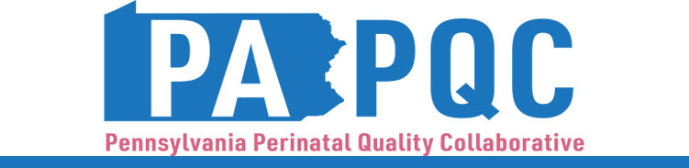

**PA PQC Virtual Learning Session**

**Thursday, June 27**

**11:00 a.m. to 12:00 p.m. ET**

**Virtual**

Zoom link will be sent to the email address you provided during registration

**Learning Objectives:**

1. Describe the importance of human donor milk to premature and medically fragile infants.
2. Describe the new guidelines and recommendations on HIV and breastfeeding.
3. Discuss the value of breastfeeding for babies who are experiencing Neonatal Abstinence Syndrome.
4. Discuss the importance of a safe sleep environment for breastfeeding babies.

**Agenda:**

11:00 a.m. to 11:05 a.m. – **Welcome** –Sara Nelis, RN, Project Manager, Jewish Healthcare Foundation

11:05 a.m. to 11:45 a.m.– **Breastfeeding Topics** –Dottie Schell, BS, RN, CLC, Director of Breastfeeding Programs PAAAP, and Devon Gilinger, MPH, CHES, CLC, Program Manager of Breastfeeding Programs at PA Chapter, American Academy of Pediatrics

11:45 a.m. to 11:55 a.m.– **Q&A**

11:55 a.m. to 12:00 p.m.– **Wrap-up & Next Steps –** Sara Nelis, RN