EpicCare Sprint Sessions
June 27, 2024
Step 1, 2 and 3 must be complete before July 7th at midnight.

Step 1 Go to http://cce.upmc.com/code

Step 2 Login to your account: If you are a new user, access http://cce.upmc.com to create an account.

Step 3: Submit attendance code: PUXVUV

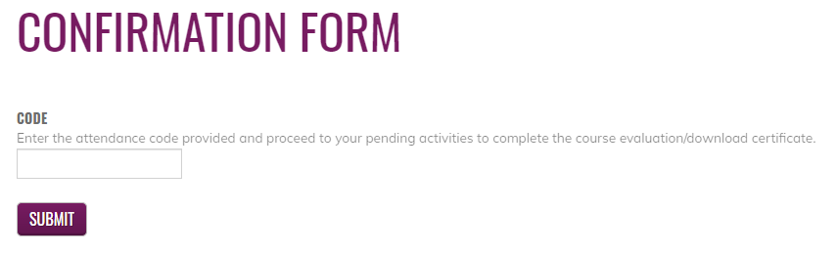

Step 4: Go to My Account, My Activities, Choose Pending Activities.

Step 5: Click on the course title to complete the course evaluation.

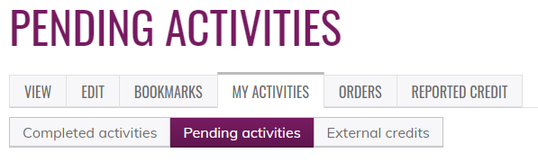

Certificates will be available to download and stored for future reference.

