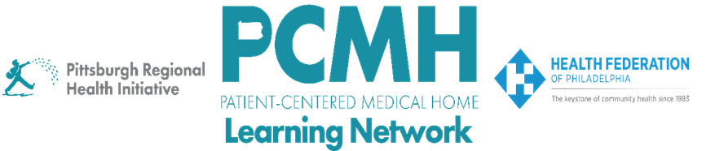

**HealthChoices PCMH Learning Network**

**Western PA Session**

**Tuesday, July 16**

**8:30 a.m. to 4:00 p.m.**

**Pittsburgh Airport Marriott**

**777 Aten Rd, Coraopolis, PA**

**Learning Objectives:**

* Discuss how to work with patient/family advisories to develop, use, and continuously improve patient-centered language for SDOH screening and feedback
* Describe PCMH processes and team roles for SDOH screening, feedback, documentation, and connection to services
* Describe resources for connecting patents to employment, transportation, health plan, housing, and transportation services

**Agenda**

8:00 a.m. to 8:30 a.m. – **Registration and Continental Breakfast**

8:30 a.m. to 8:40 a.m. – **Welcome and Introduction** – Robert Ferguson, MPH, Chief Policy Officer, Pittsburgh Regional Health Initiative (PRHI)

8:40 a.m. to 9:40 a.m. – **Small Group Discussion on Report Out Questions**

**SDOH Screening Discussion:** What is your current workflow and tools for SDOH screening and follow-up? What improvements have you made over time and why? What hasn’t worked well or what barriers have you encountered?

**Family/Patient Input Discussion:** What type of feedback on SDOH screening and follow-up have you received from patients and/or formal patient/family advisors? If you haven’t received any feedback, what are the patient/family councils, board members, or advisors at your organization whom you could connect with to receive feedback?

**SDOH Partnership Discussion:** Which community agencies has your PCMH developed a working relationship to improve SDOH referrals and to close the loop on those referrals? Which tools, such as PA Navigate (Find Help), are supporting this communication process?

9:40 a.m. to 9:50 a.m. – **Break**

9:50 a.m. to 10:55 a.m. – **Presentation: SDOH Screening and Follow-up based on Feedback from Patient/Family Advisors** –Kristen Macey**,** Project Manager - Extended Care Teams**,** Primary Care Institute**,** Allegheny Health Network and Laurie Weidner, Director, Practice Transformation

AHN Value-Based Care

10:55 a.m. to 11:10 a.m. – **Action Planning Exercise: Involving Patient/Family Advisors to Continuously Improve SODH Screening and Follow-up**

11:10 a.m. to 11:20 am – **Break**

11:20 a.m. to 12:00 p.m. – **Part 1 Workshop: Patient-Centered Language for SDOH Screening** – Facilitated by Mae Reale, MA, Health Education Specialist, Pennsylvania Coalition Against Domestic Violence

12:00 p.m. to 1:00 p.m. – **Lunch**

1:00 p.m. to 1:45 p.m. – **Part 2 Workshop: Practing Patient-Centered Language for SDOH Screening and Warm Handoffs** – Facilitated by Mae Reale, MA, Health Education Specialist, Pennsylvania Coalition Against Domestic Violence

1:50 p.m. to 2:10 p.m. – **Break**

2:10 p.m. to 3:15 p.m. – **Knowledge Cafes: Connecting with SDOH Community Resources**

**WIC**

Staci L. Bose, MS, Operations Manager WIC, Allegheny County Health Department

**MCO Special Needs Unit**

Jessica Rhodes, Director of Clinical Programs, UPMC for You

Katie Rose LSW, CCM, Community Based Supervisor, Clinical Operations, Highmark Wholecare

Diana Lowry MSW, LSW, CCM, Medical Case Manager and SNU Coordinator, Clinical Services, Highmark Wholecare

**PA Navigate**

Laura A. Mosesso, Client Services Manager, ClinicalConnect

Carly Pasinski, System Analyst, ClinicalConnect

**Housing**

Cheryld Emala MSW, LCSW, Chief Operating Officer, Executive of CONNECT Inc.

**Community Action Agencies**

Pamela Jeneé Wilbon, Chief Operating Officer, Pittsburgh Community Services Inc

3:15 p.m. to 3:50 p.m. – **Huddles and Report Outs** – Facilitated by Jen Condel, Robert Ferguson, and Lisa Boyd

3:50 p.m. to 4:00 p.m. – **Wrap-Up**