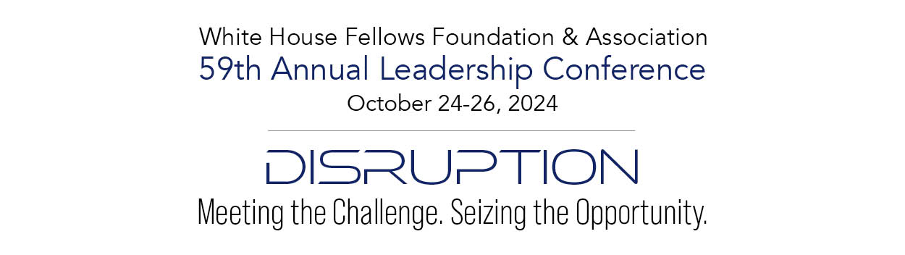

Venues:

Wednesday – Virtual Workshop

Thursday Morning and Afternoon – Decatur House: 748 Jackson Place, NW, Washington, DC

Thursday Evening – The Hirshhorn Museum and Sculpture Garden

Independence Ave SW & 7th St SW, Washington, DC

Friday Morning and Afternoon – Decatur House: 748 Jackson Place, NW, Washington, DC

Saturday – Lincoln Cottage**:** 140 Rock Creek Church Road NW, Washington DC

**WEDNESDAY, OCTOBER 23, 2024**

**Strategic Foresight Workshop**

**Location**: Virtual – a link will be provided beforehand to registered attendees

**Time**: 1:00pm to 5:00pm ET

On Wednesday, the day *before* the Annual Leadership Conference, Ms. Robin Champ, VP Strategic Foresight at LBL Strategies will lead this 4-hour virtual workshop. The workshop can accommodate up to 30 people. Those who participate will receive Continuing Education Credits awarded by The George Washington University. This workshop will be available for a separate registration fee.

Topics covered will include:

* Foresight in the Government
* Foresight and Strategy
* Deep Dive: Signals and Trends
* PESTLE/STEEP/STEEPLE Frameworks
* Futures/Implications Wheels
* Scenario-Based Planning

**THURSDAY, OCTOBER 24, 2024**

**Decatur House**: 748 Jackson Place, NW, Washington, DC

Attire: Business

Note: Sessions highlighted in green will be available to watch “remote” by WHFs who wish to view these selected conference sessions at a reduced registration rate.

7:30am Registration opens, informal networking, and breakfast in the courtyard.

8:50am Welcome and Opening Remarks by WHFFA President **Mr. Marc Thomas** (1994-95) and WHFFA Vice President **Dr. Sharon Kiely** (1994-95)

Special Recognition:

* + 50th Anniversary Class: **The Class of 1974-75**
  + Featured artist: **TBD**

9:00am: Keynote Speaker: **Dr. Doris Kearns-Goodwin** (1967-68) – ***Confirmed***

* Introduced by: **TBD**

10:00am: Break

10:15am: Panel: ***Disruption in the Legislative Branch***

Moderated by **TBD**

Panelists:

* **Honorable Patrick Murphy** Former U.S. [Representative](https://en.wikipedia.org/wiki/United_States_House_of_Representatives) (D-FL-18) – ***Confirmed***
* **Honorable Tom Rooney**,Former U.S. [Representative](https://en.wikipedia.org/wiki/United_States_House_of_Representatives) (R-FL-16/17) – ***Confirmed***

11:05am: Break

11:20am: Speaker – TBD

12:00pm Break and shift from Carriage House to the Courtyard

12:10pm Luncheon served

12:30pm Commission Luncheon:

* **Ms. Demetra Lambros**, Chair of the President’s Commission on White House Fellowships – ***Confirmed***
* **Ms. Rose Vela**, Director of the President’s Commission on White House Fellowships – ***Confirmed***
* Introduced by **TBD**

1:00pm Break and time to talk with your “fellow Fellows”

1:20pm Shift venue to Carriage House

1:30pm Speaker: **The Honorable Lael Brainard** (1994-95), Director, National Economic Council – ***Confirmed***

* Introduced by: **TBD**

2:20pm: Break

2:30pm: Panel: ***“Strategic Foresight”***

Moderated by **Ms. Robin Champ**, Vice President of Strategic Foresight for LBL Strategies – ***Confirmed***

Panelists:

* + - * + **Mr. Eric Popiel**, Group Manager, Future of Work, Workforce Policy & Innovation, U.S. Office of Personnel Management – ***Confirmed***
        + **Mr. James Christian Blockwood**, Executive Vice President, Partnership for Public Service – ***Confirmed***

3:30pm: Break

3:40pm: Speaker: **Ms. Anne Neuberger** (2007-08), Deputy National Security Advisor, Cyber & Emerging Technology – ***Confirmed***

* Introduced by: **TBD**

4:30pm: Possible Smithsonian Curator to give us a pre-briefing on the Hirshhorn

4:50pm: Closing Remarks for Day 1: WHFFA President **Mr. Marc Thomas** (1994-95) and WHFFA Vice President **Dr. Sharon Kiely** (1994-95)

5:00pm: Break and shift venue to the *Hirshhorn Museum and Sculpture Garden*

7:00pm **Arrive at the *Hirshhorn Museum and Sculpture Garden***

7:00pm: **Reception**

8:00pm: Tour the exhibits in the downstairs Kruger Lobby and the “**Revolutions Exhibition**” on the 2nd Floor

* Please Note: Food and drink will not be permitted in the 2nd Floor exhibits

9:00pm: Evening events conclude

**FRIDAY, OCTOBER 25, 2024**

**Decatur House**: 748 Jackson Place, NW, Washington, DC

Attire: Business

7:30am Registration opens, informal networking, and breakfast in the courtyard.

9:00am Speaker: **Mr. Jon Finer** (2009-10), Principal Deputy to the National Security Advisor– ***Confirmed***

* Introduced by: **TBD**

9:45am: Break

10:00am: Panel: ***Immigration: Policy, Politics, and Public Safety***

Notes: Proposing Fellows: Elizabeth Daitz (2019-2020) and Chris Moore (1999-2000). Speaker: **The Honorable Alejandro Mayorkas,** Secretary of Homeland Security – ***Tentatively*** ***Confirmed*** (awaiting final confirmation)

11:00am: Break

11:15am: **The Honorable Carlos Del Toro** (1998-99), Secretary of the Navy – ***Confirmed***

* Introduced by: **TBD**

12:00pm Break and shift from the Carriage House to the Courtyard

12:10pm Luncheon Served

12:25pm *White House Fellows Foundation & Association Business Meeting*

* President’s Report – WHFFA President **Mr. Marc Thomas** (1994-95)
  + Treasurer’s Report – WHFFA Treasurer **Mr. Kevin Monroe** (1996-97)
  + Clinton Presidential Library – Executive Director **Mr. David Moore** (1996-97)
* WHF Recruiting Report – **CAPT Robert “Mac” McFarlin**, USN (2013-14)

1:10pm Break and time to talk with your “fellow Fellows”

1:30pm: Panel: ***Leading Through Disruption: WHF Alumni Confronting Instability in East Africa***

Notes: Proposing Fellow: Dr. Dakota Roberson (WHF 2019-2020); Speakers: Dr. Brian D’Silva, [https://www.reuters.com/article/idUSBRE86A0GD](https://www.reuters.com/article/idUSBRE86A0GD/), Former USAID Senior Policy Advisor on Sudan and South Sudan (confirmed); Joy Basu (WHF 2021-2022), Deputy Assistant Secretary of African Affairs (confirmed); Dr. David Rogers (WHF 2018-2019), Chief Development Officer, Research & Development Corp. (confirmed)

2:30pm: Break

2:45pm: Speaker – TBD

3:30pm: Break

3:45pm Panel #3: Topic TBD

Moderated by: TBD

Panelists: TBD

4:55pm Closing Remarks by incoming WHFFA President **Mr. Will Webb** (1994-95)

5:00pm **Begin Evening Reception in the Courtyard**

Potential activities include introducing the new class, and/or an award presentation

7:00pm Evening free for Class Dinners/Gatherings

**SATURDAY, OCTOBER 26, 2024**

**Lincoln Cottage:** 140 Rock Creek Church Road NW, Washington DC 20011

10:00am Arrive at the Cottage grounds via car, or Uber/Lyft. Directions to the cottage will be provided in your conference folder.

On arrival, we will break into two or more groups of 25 people. One group will tour the cottage while the other group participates in the program: ***Lincoln’s Toughest Decisions***: *A facilitated, dialogue-based, interactive experience designed to help participants work through the toughest decisions President Lincoln made around Emancipation*. The groups with then switch and the group that has toured the cottage will participate in the program, and vice versa.

11:30am Programs and Tours completed.

11:30am Lunch

We will then gather at the Visitor Education Center Group for a picnic on the lawn. [Note: In the event of inclement weather, we will have lunch in the Group Program Room at the Visitor Education Center].

12:30pm Tour ends