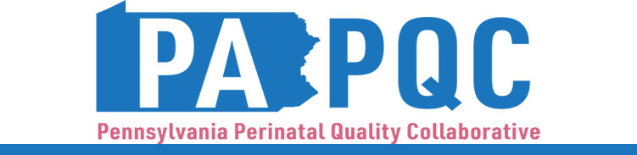

**PA PQC Virtual Learning Session**

**Maternal Initiative Peer-to-Peer Learning**

**Monday, September 23**

**11:00 a.m. to 12:00 p.m. ET**

**Virtual**

Zoom link will be sent to the email address you provided during registration

**Learning Objective:**

* Discuss team successes and challenges so far and plans for the duration of the 2024-25 Implementation Period in the Opioid Use Disorder and Maternal Sepsis initiatives.

**Agenda:**

11:00 a.m. to 11:02 a.m. – **Welcome** –Sara Nelis, RN, Program Manager, Jewish Healthcare Foundation

11:02 a.m. to 11:07 a.m.– **PA PQC Quarterly Data Report** –Lisa Boyd, BA, Program Associate, Jewish Healthcare Foundation

11:07 a.m. to 11:15 a.m.– **Holy Redeemer Hospital** –Helene Coakley, BSN, RN, OB Substance Use Disorder Nurse Navigator

11:15 a.m. to 11:25 a.m.– **Site** –Champion

11:25 a.m. to 11:35 a.m.– **Site** –Champion

11:35 a.m. to 11:45 a.m.– **Site** –Champion

11:45 a.m. to 11:55 a.m.– **Site** –Champion

11:55 a.m. to 12:00 p.m.– **Wrap-up & Next Steps –** Sara Nelis, RN