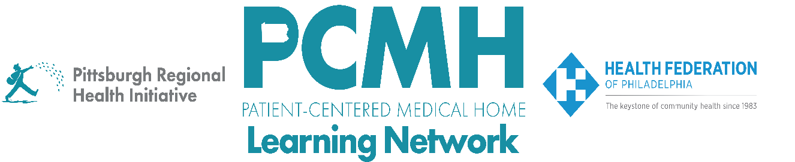

**HealthChoices PCMH PNC Learning Network**

**Overview of the HealthChoices PCMH PNC Program &**

**Medical Necessity Criteria for Authorizing Shift Care Services**

**Thursday, September 5 from 11:00am – 12:00pm**

**Learning Objectives**

* Describe the goals of the HealthChoices PCMH Pediatric Nursing Care program
* Describe the Pediatric Shift Care medical necessity criteria for authorizing shift care services and the available resources

**Agenda**

9:00 a.m. to 9:02 a.m. – **Welcome and Overview** –Robert Ferguson, MPH, Chief Policy Officer, Pittsburgh Regional Health Initiative (PRHI)

9:02 a.m. to 9:10 a.m. –**Overview of the HealthChoices PCMH-PNC Program –** Latesia Sease, HSPS Supervisor-Process Management Unit, Division of Quality and Special Needs Coordination, Department of Human Services - Bureau of Managed Care, Office of Medical Assistance Programs

9:10 a.m. to 9:45 a.m. –**PCMH Medical Necessity Criteria for Authorizing Shift Care Services -** Donald Quigley RN, Clinical Quality Supervisor, Division of Quality and Special Needs Coordination, Department of Human Services - Bureau of Managed Care, Office of Medical Assistance Programs

9:45 a.m. to 10:00 a.m. – **Q&A and Discussion –** Carol Frazer, Pittsburgh Regional Health Initiative (PRHI)