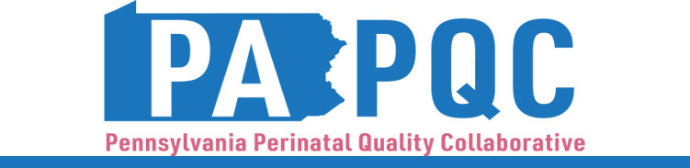

**PA PQC Virtual Learning Session**

**Neonatal Initiative Peer-to-Peer Learning**

**Monday, September 16**

**2:00 p.m. to 3:00 p.m. ET**

**Virtual**

Zoom link will be sent to the email address you provided during registration

**Learning Objective:**

* Discuss team successes and challenges so far and plans for the duration of the 2024-25 Implementation Period in the Safe Sleep and Neonatal Abstinence Syndrome initiatives.

**Agenda:**

2:00 p.m. to 2:05 p.m. – **Welcome** –Kristen Brenneman, MSN, RNC-NIC, Quality Improvement Facilitator, Jewish Healthcare Foundation

2:05 p.m. to 2:10 p.m.– **PA PQC Quarterly Data Report** –Lisa Boyd, BA, Program Associate, Jewish Healthcare Foundation

2:10 p.m. to 2:55 p.m. – **Breakout Rooms**

***Safe Sleep Breakout Room*** – facilitated by Lisa Boyd, BA:

*UPMC Children’s Hospital of Pittsburgh* – Spencer Bowersox, MSW, LCSW, Senior Clinical Social Worker and Katrina Warner, BSN, RN, CCRN, CBC, Clinician, Neonatal Intensive Care Unit

*Guthrie Robert Packer Hospital*–Jessica Miller, CNM, Certified Nurse Midwife

***NAS Breakout Room*** – facilitated by Kristen Brenneman, MSN, RNC-NIC:

*Einstein Medical Center Philadelphia* –Maryann Maloy, DNP,RN,RNC-NIC,RNC-ONQS,NEA-BC, Nurse Manager

*Geisinger Lewiston Hospital* –Jackie Skiba, RN, BSN, Geisinger Operations Manager, Western Region Outpatient and Pediatric Clinics

2:55 p.m. to 3:00 p.m.– **Wrap-up & Next Steps –** Kristen Brenneman, MSN, RNC-NIC