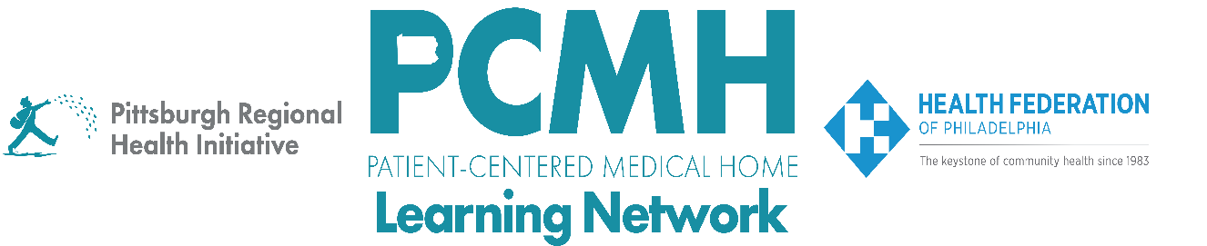

**HealthChoices PCMH Learning Network**

**September Statewide Session**

**Hepatitis C Care in Perinatal and Pediatric Settings**

**Tuesday, September 11**

**12:00 p.m. to 1:00 p.m.**

**Learning Objectives**

* Describe best practices for Hepatitis C screening and treatment for pregnant individuals
* Discuss the consequences of perinatal Hepatitis C transmission and approaches for screening infants

**Agenda**

12:00 p.m. to 12:05 p.m. – **Welcome and Overview** –Robert Ferguson, MPH, Chief Policy Officer, Pittsburgh Regional Health Initiative (PRHI)

12:05 p.m. to 12:45 p.m. – **Hepatitis C Care in Perinatal and Pediatric Settings**– Catherine Chappell, MD, MSc, Assistant Professor, Department of Obstetrics, Gynecology and Reproductive Science at the University of Pittsburgh School of Medicine and Anne-Marie Rick, MD, MPH, PhD, Assistant Professor of Pediatrics and Clinical and Translational Science at the University of Pittsburgh School of Medicine

*Through a case-based learning approach, Catherine Chappell, MD MSc and Anne-Marie Rick, MD, MPH, PhD will describe how to screen for and treat Hepatitis C in pregnancy, including the consequences of perinatal transmission and screening of infants.*

12:45 – 12:55 pm – **Q&A** –moderated byRobert Ferguson, MPH, Chief Policy Officer, Pittsburgh Regional Health Initiative (PRHI)

12:55 p.m. to 1:00 p.m. – **Wrap-Up** – Lisa Boyd, Program Associate, Pittsburgh Regional Health Initiative (PRHI)