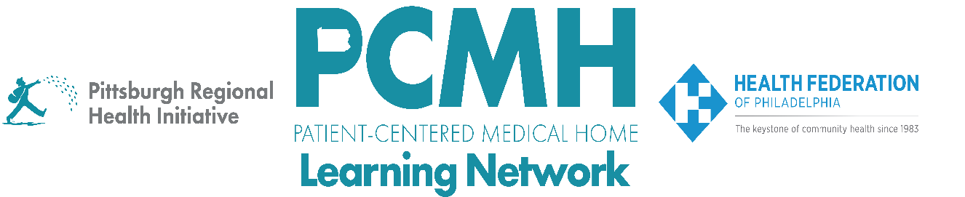

**HealthChoices PCMH Learning Network**

**September Statewide Session**

**Vaccination Rates and Strategies in Pennsylvania**

**Tuesday, September 10**

**1:00 p.m. to 2:00 p.m.**

**Learning Objectives**

* Describe the vaccination rates by age, race, ethnicity, and geography in Pennsylvania and the populations at greatest risk
* Discuss the forecasted supply and guidelines for flu, pneumococcal, Tdap, COVID, and maternal RSV vaccines
* Describe how to use the current functionality of the PA Immunization Electronic Registry System
* Describe strategies for how to know whether the child was born to a mother who did not receive the RSV vaccine
* Discuss effective messages and communication strategies about vaccines for different patient populations in Pennsylvania

*Agenda:*

1:00 p.m. to 1:05 p.m. – Welcome & Introductions – Robert Ferguson, MPH, Chief Policy Officer, Pittsburgh Regional Health Initiative

1:05 p.m. to 1:18 p.m. – Immunization Rates in PA – Sarah Rosado, RN, BSN, PA DOH

1:18 p.m. to 1:30 p.m. – Vaccination Supply and Guidelines – Julie Myers, MPH, Public Health Program Manager , PA DOH Division of Vaccine Operations and Provider Services

1:30 p.m. 1:42 p.m. – ​​​​​​Pennsylvania Immunization Electronic Registry System (PIERS) – Virginia Kise, PIERS Outreach and Training Coordinator, PA DOH Bureau of Immunizations

1:42 p.m. to 1:58 p.m. – PCMH Q&A and Peer-to-Peer Discussion – Facilitated by Jennifer Condel, SCT(ASCP)MT, Manager, Lean Healthcare Strategy and Implementation, Pittsburgh Regional Health Initiative

1:58 p.m. to 2:00 p.m.  – Wrap-Up – Lisa Boyd, Program Associate, Pittsburgh Regional Health Initiative