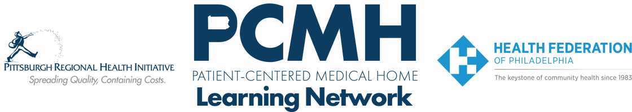

**HealthChoices PCMH Learning Network**

**Southeastern PA**

**Wednesday, October 23rd**

**8:30 a.m. to 10:30 a.m.**

Register: [SEPA Fall Session](https://content.jhf.org/e3t/Ctc/DO+113/d2xDfT04/VWrcB97Rms8nW4XQdWL8m0mfKW99f7mw5jpJjcMwF3TT3qgyTW8wLKSR6lZ3lCMvPXBpRTk2PW2zc_DW5JQKJbW3lC68-37PmrhW1kzZh46b4jbQW7QkFtk7QmPJvVYPPVn4-f86TW6n9r-83znnpVW4qwDck7jqnCrW45rvFW2Y8nNjW2mTC-85j480sW4xfVvf2BJ9SnW5zxLr22_M-71W3p2yfr1YHZhxW8hKMcB2CFyDYW6YK1vH8v3KYrVDtyyx20q-3qVFmGpY1jY26fW5-bd7l2JMfSpW6CDzB946BBMmN8hnRz4X0Q0cW7g8Mfd6tl6KFW5z98C78vzP0nW6KnWQV5qgv90W7sXyJM7lQb9TW8pXLkx2kl5v8W5zcWTB7zHnWwN38_5z-S-kpQW2YBhyM6NR3Cvf1HcX0-04)

Learning Objectives:

* Identify skills for engaging people who use drugs in primary care.
* Learn practices to promote harm reduction.
* Describe approaches to integrating treatment for substance misuse in primary care.
* Identify steps to adopting treatment to address substance misuse in primary care.

**Agenda:**

8:30 a.m. to 8:40a.m. – **Welcome** – Suzanne Cohen, Senior Director of Population Health, The Health Federation of Philadelphia

8:40 a.m. to 9:30 a.m. – **Engaging People Who Use Drugs in Primary Care** – Rachael Truchil, MD, MPH, Associate Professor of Clinical Medicine, Division of General Internal Medicine, Nicole O’Donnell, Recovery Specialist, Penn Medicine

9:30 a.m. to 10:25 a.m. – **Addressing Substance Use Disorder in Primary Care** – David T. O’Gurek, MD, FAAFP, Associate Chief Medical Executive, Innovation Equity and Wellness Primary Care Service Line, Department of Family Medicine, LVPG Family Medicine – Lehighton

10:25 a.m. to 10:30 a.m. – **Wrap Up & Evaluation**