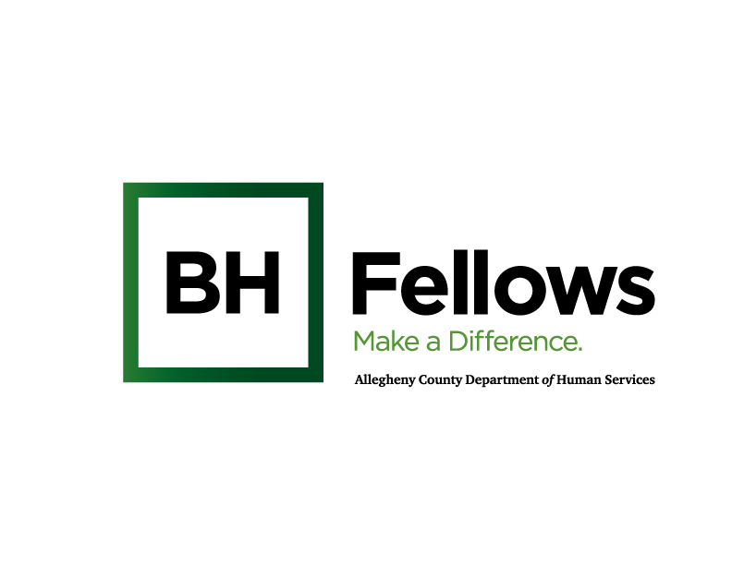
Working Draft 9.3.24
Cohorts 2, 3 and 4
October 10, 2024
9:00am – 12:00pm

Virtual Zoom:
Meeting ID:
Passcode:

SW Credit Course Title: Ethical Guidelines and Principles for Behavioral Health Professionals
Requesting: 1.5 credit hours for SW

Learning Objectives:
- Review principles of bioethics and concept of moral sensitivity
- Explore challenges to the primacy of autonomy when patients/clients refuse recommendations
- Examine morally supportable strategies when working with clients who disagree with recommendations

Time | Component | Content | Presenter/Facilitator
8:30 AM | Check-in | Open Zoom Meeting  Jess will open  - make all JHF staff co-hosts  - hit record  - spotlight speakers | -Jess  -Scotland: screenshots  -Jen: monitor chat, run breakouts
8:50 AM |  | Tech check with Adele  Jen to run slides
9:05 AM | Welcome & Introductions | Open with Sanctuary Model  - How are you feeling today?  - What do you need from the group or someone in the room?  - What will you bring to the group?  Intro: name, role, org  Share: a tip pertaining to ethical guidelines or principles in your work or a support/resource from your organization that has been helpful in terms of ethics  Reflections  - What has been your experience since our last session?  - Introduce Ariel and Rebekah | Carol Frazer, MEd, LPC,  Behavioral Health Specialist,  Pittsburgh Regional Health Initiative  Bridget McNamee, MID, Behavioral Health Project Manager, Jewish Healthcare Foundation
9:30 AM | Ethics  (20 mins) | Ethical Guidelines and Principles for Behavioral Health Professionals  - Review of principles of bioethics and moral sensitivity | Ariel Clatty, PhD  Ethics Consultant, University of Pittsburgh  Rebekah Apple, MA, DHSc  Director, Master of Medical Management  Heinz College of Information Systems and Public Policy  Carnegie Mellon University
9:50 AM | (15 mins) | Introduction
10:05 AM | (15 mins) | Breakout discussions on patients' right to say "no"
10:20 AM | (10 mins) | Debrief from first breakout session
10:30 AM | (10 mins) | Discussion on morally supportable strategies
10:40 AM | (10 mins) | Breakout discussions on challenges regarding strategies
10:50 AM | (10 mins) | Debrief, conclusion
11:00 AM | Wellness Practices | Mindfulness Activity (?)  JFCS (Jewish Family and Community Services) Playlist:  Mental & Emotional Health Exercises - YouTube  Fellows welcome to pick a video or other mindfulness activity | Bridget
11:30 AM | Wrap-up and Reminders | Reflections and Take-aways:  - Aha’s from the session  - Reflection Questions (How support one another over the course of the cohort?)  - Next session:  - CEU Survey Deadline: October 17th  4 question survey at end of session  *CEU email: Jen send October 11th, deadline for completion is October 17th | Bridget
12:00 PM | Departure

