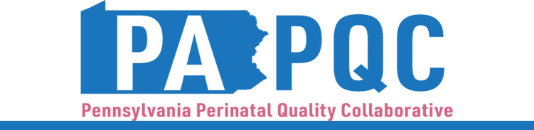

**PA PQC Virtual Learning Session**

**PA MMRC Findings & Regional Breakouts**

**Thursday, October 24**

**11:00 a.m. to 12:30 p.m. ET**

**Virtual**

Zoom link will be sent to the email address you provided during registration

**Learning Objective:**

* Describe the most recent PA MMRC and SMM findings and recommendations.
* Discuss regional-specific needs and topics, related to this year’s PA PQC focus areas of OUD (opioid use disorder), NAS (neonatal abstinence syndrome), obstetric sepsis, and safe sleep.

**Agenda:**

11:00 a.m. to 11:05 a.m. – **Welcome** –Sara Nelis, RN, Program Manager, Jewish Healthcare Foundation

11:05 p.m. to 11:35 a.m.– **Severe Maternal Morbidity and Mortality in Pennsylvania: Unpacking the Data** –Dr. Aasta Mehta, MD, MPP, Philadelphia Department of Public Health

11:35 a.m.to 12:25 p.m.– **Regional Breakouts**

***Northwest*** – facilitated by Jennifer Condel, SCT(ASCP)MT, Manager of Lean Healthcare Strategy and Implementation, Jewish Healthcare Foundation

***Northeast*** – facilitated by Sara Nelis, RN

***Southeast*** – facilitated by Maureen Saxon-Gioia, MS HSA, RN, Nurse Project Manager, Jewish Healthcare Foundation

***Southwest*** – facilitated by Lisa Boyd, BA, PQC QI Coach & Data Manager, Program Associate, Jewish Healthcare Foundation

***Lehigh/Capitol*** – facilitated by Kristen Brenneman, MSN, RNC-NIC, Quality Improvement Facilitator, Jewish Healthcare Foundation

12:25 p.m. to 12:30 p.m.– **Wrap-up & Next Steps –** Sara Nelis, RN