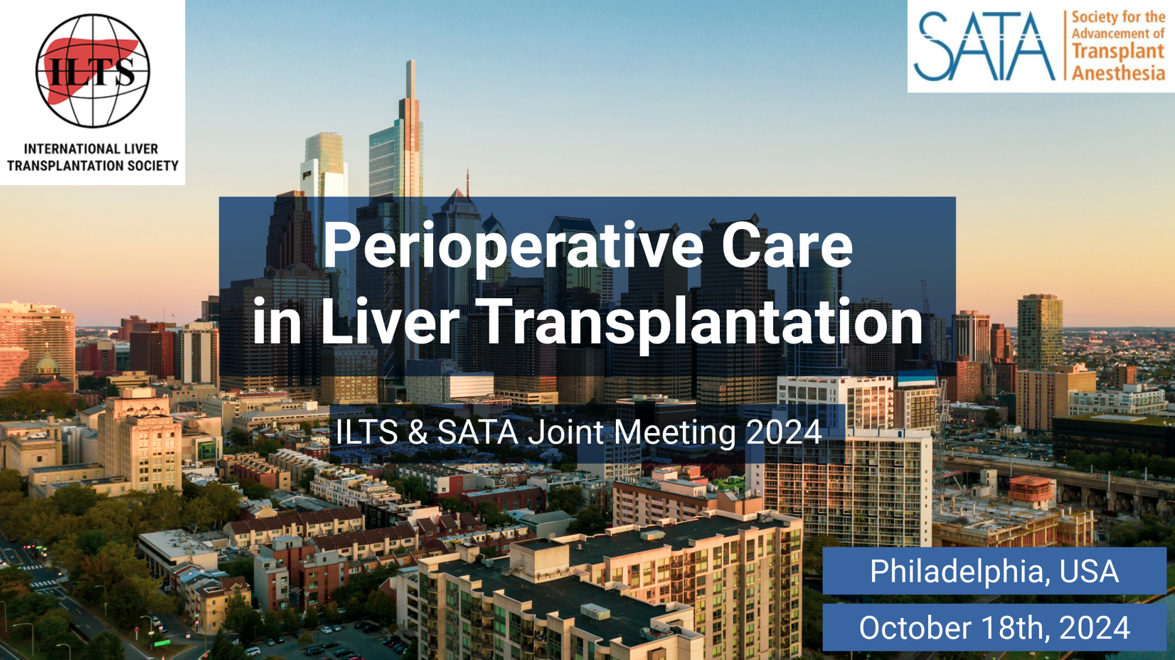

**Please join us on October 18th for the 2024 Perioperative Care in Liver Transplantation meeting, jointly organized by the International Liver Transplant Society (ILTS) and the Society for the Advancement of Transplant Anesthesia (SATA) at the**

**Jefferson University – Jefferson Alumni Hall**

**Eakins Lounge**

**1020 Locust St. Philadelphia, PA, 19107**

**On Friday, October 18, 2024**

|  |  |  |
| --- | --- | --- |
| **Registration fees** | Before October 18, 2023 | On October 18, 2023 |
| ILTS and SATA members (SCA, SOCCA) | $150 | $180 |
| Non-members | $200 | $250 |
| Reduced fee for non-physicians attendees | $100 | $120 |

**Registration website:**

[**https://sata2022.wufoo.com/forms/q1ntq3km0r0bvxj/**](https://sata2022.wufoo.com/forms/q1ntq3km0r0bvxj/)

**2024 ILTS/SATA Perioperative Care in Liver Transplantation**

**7:15 am – 7:50 am Registration  
7:50 am – 8:00 am Welcome and Introduction**

**8:00 am – 8:55 am New Standards of Care for LT recipients and donors**

*Moderators: Marina Moguilevitch - Montefiore Medical Center, NY,USA*

*Natalie Smith - Mount Sinai, New York, NY, USA*

8:00 am – 8:15 am ***Living donation for patients with porto-pulmonary hypertension***

*Andrew Gold - University of Pennsylvania, Philadelphia, PA, USA*

8:15 am – 8:30 am ***How do we treat hepato-pulmonary syndrome?***

*Sergio Navarrete - Virginia Commonwealth University, Richmond, VA, USA*

8:30 am – 8:45am ***Standards for Donor Care worldwide***

*Varun Goyal - University of Texas, San Antonio, TX, US*

8:45 am – 8:55 am*Discussion*

**8:55 am – 9:15 am Break**

**9:15 am – 10:10 am** **Perioperative Management Challenges**

*Moderator: Marina Gitman - University of Miami, FL, USA*

9:15 am – 9:30 am **Liver transplantation for patients on anticoagulation**

*Linda Liu - UCSF, San-Francisco, CA, US*

9:30 am – 9:45 am **The role of the perfusionist in transplantation**

*John Kernan - University of Pennsylvania, Philadelphia, PA, USA*

9:45 am – 10:00 am **Perioperative pain management and fast track anesthesia**

*Ryan Nazemian -* *Lahey Clinic, MA, USA*

10:00 am – 10:10 am*Discussion*

**10:10 am – 10:30 am Break**

**10:30 am – 11:30 am Pro/Con Debate:**

*Moderators: Govind Rangrass - St. Louis University Hospital, St. Louis, MO, USA*

*Christine Nguyen-Buckley - UCLA, Los Angeles, CA, USA*

10:30 am – 10:50 am **Pro:** We should do machine perfusion for all LT, not just DCD

*Eduardo Fernandes – The Cleveland Clinic, Weston, FL, USA*

10:50 am – 11:10 am **Con:** Machine perfusion for all LT is not necessary, even for DCD

*Erika Fagelman - Mount Sinai, New York, NY, USA*

11:10 am – 11:20 am*Discussion*

**11:20 am – 1:00 pm Lunch Break and Workshops**

**1:00 pm – 2:00 pm Case Presentations**

*Moderators: Ryan Chadha - Mayo Clinic, Jacksonville, FL, USA*

*Coridalia Wald - University of Massachusetts, MA, USA*

1:00 pm – 1:30 pm **Case 1:** *Arun Shankar - Lahey Clinic, MA, USA*

1:30 pm – 2:00 pm **Case 2:** *Elizabeth Townsend - University of Wisconsin, WI,USA*

**2024 ILTS/SATA Perioperative Care in Liver Transplantation**

**-Continued -**

**2:00 pm – 2:15 pm Break**

**2:15 pm – 3:15 pm ILTS Cardiovascular Special Interest Group (SIG)**

*Moderators: Taylor Lloyd - MGH, Boston, MA, USA*

*Christopher Wray - UCLA, Los Angeles, CA, USA*

2:15 pm – 2:30 pm **LVOT obstruction (dynamic + anatomical): When is it too much?**

Jacek Cywinski *-* Cleveland Clinic, Cleveland, OH, US

2:30 pm – 3:00 pm **CCTA should replace the stress test for pre-transplant cardiac evaluation of liver transplant candidates (Pro/Con)**

***Pro:*** *Dempsey Hughes - Northwestern University, Chicago, IL, USA*

***Con:*** *Sahi S. Banka - Jefferson Einstein Hospital Philadelphia, Philadelphia, PA, USA*

3:00 pm – 3:15 pm **Establishing cardiac risk for liver transplant candidate: the building and implementation of an algorithm**

*Vandana Khungar - Yale University, New Haven, CT, USA*

3:15 pm – 3:30 pm *Discussion*

**3:30 pm – 3:45 pm Break**

**3:45 pm – 4:40 pm Searching for Ways to Improve Outcome**

*Moderators: Thomas Verbeek - Penn State University, Hershey, PA, USA*

*Fuat Saner –* King Faisal Specialised Hospital & Research Center, Riyadh/KSA

3:45 pm – 4:00 pm**Are we running out of indications for liver transplants, now that hepatitis C is gone?**

*Hoteit Maarouf - University of Pennsylvania, Philadelphia, PA, USA*

4:00 pm – 4:15 pm**Does it really matter? How anesthesiologists affect outcome**

*Samuel Demaria - Mount Sinai, NY,USA*

4:15 pm – 4:30 pm**Do we care about fibrinolysis? Antifibrinolytics, cryoprecipitate, PCC and thrombosis?**

*Uzung Yoon – Jefferson University, Philadelphia, PA, USA*

4:30 pm – 4:40 pm*Discussion*

**4:40 pm – 5:15 pm The Future of Liver Transplantation**

*Moderators: Dmitri Bezinover - University of Pennsylvania, Philadelphia, PA, USA*

4:40 pm – 4:55 pm**Xenotransplantation**

*Emily Vail - University of Pennsylvania, Philadelphia, PA, USA*

4:55 pm – 5:05 pm**The future of ILTS: A message from the ILTS president**

*Nazia Selzner - University of Toronto, Toronto, Canada*

5:05 pm – 5:15 pm**Closing remarks**

*Gebhard Wagener - Columbia University Medical Center, New York, NY, USA*