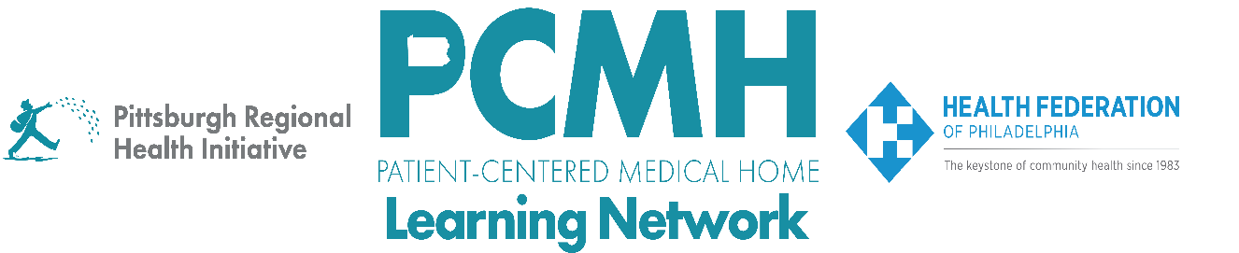

**HealthChoices PCMH PNC Learning Network**

**Pediatric Complex Care Resource Centers (PCCRCs)**

[**Wednesday, October 16 from 12:00 pm – 1:30 pm**](https://us06web.zoom.us/meeting/register/tZIlceCvrj4uHNX9pb498ZtJvH-B4lL7dEno?utmregistration)

**Learning Objectives**

* Describe the goal and services of the Pediatric Complex Care Resource Centers (PCCRC)
* Describe an example of how a regional PCCRC operates
* Discuss opportunities for how PCCRCs can collaborate with PCMH-PNCs

**Agenda**

12:00 p.m. to 12:03 p.m. – **Welcome and Overview** –Robert Ferguson, MPH, Chief Policy Officer, Pittsburgh Regional Health Initiative (PRHI)

12:03 p.m. to 12:28 p.m. – **Overview of the Pediatric Complex Care Resource Centers: Goals, Structure, and Services** –Nicole Harris, Executive Director, CHIP, Office of Medical Assistance Programs, PA Department of Human Services

12:28 – 12:48 pm - **Family Facilitator Highlight** – Jennifer Harniman-Crangle, Former Family Facilitator, Office of Developmental Programs, PA Department of Human Services

12:48 p.m. to 1:28 p.m. – **Regional PCCRC Panel Discussion with PCMH-PNCs – Regional PCCRC Representatives** –Nicole Harris, Executive Director, CHIP, Office of Medical Assistance Programs, PA Department of Human Services; Moderated by Carol Frazer, MEd, LPC, Behavioral Health Specialist, PRHI

* Introductions of PCCRC Directors
* How could case managers on PCMH-PNCs interface with PCCRCs’ pediatric coaches and family facilitators to facilitate coordination of care?
* How and when would MCO SNUs also be involved?
* What training topics would be helpful for the PCCRC’s Online Training and Support Hub?

1:28 p.m. to 1:30 p.m. – **Wrap-up** – Lisa Boyd, Program Associate, Pittsburgh Regional Health Initiative (PRHI)