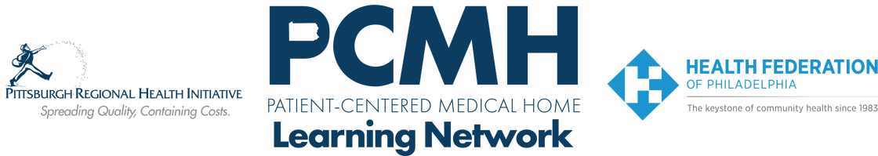

**HealthChoices PCMH Learning Network**

**Lehigh Capital PA**

**Thursday, November 7**

**8:30 a.m. to 3:15 p.m.**

**The Alexander Grass Campus for Jewish Life**

**2986 N Second Street, Harrisburg, PA 17110**

**Register:** [Lehigh/Capital Fall Session](https://content.jhf.org/e3t/Ctc/DO+113/d2xDfT04/VWrcB97Rms8nW4XQdWL8m0mfKW99f7mw5jpJjcMwF3Tg3qgyTW7lCdLW6lZ3p3VXKG0m5jdN_7W3_kPFT1KqyhHW1dQCF33z5KK8W2s8GcW3R3g1bW93j2798_F-xsN8kY4Pv_4kDdW3zK59718vwwsW5PM9B34CgxhjN2c_F9FhzRKbVjLNbC8k0hzhW9k21Dg2cQtfYW6khcPT1-N6SYW7zKQQh6JN5CgW3p-3D76X4GnRW7P7H-Y6R1M9pW1060jH3137M3W6VHR-p1KqWgPW7_R1NZ28qZfyW7Cw_C2265tY4W3V751Q6XT9rhV_8ClM3-L1w-W8NYzbr3mXx31W88q8fB5PSp93W6BBC-82GwCrWf3bylzR04) –

**Learning Objectives:**

* Identify skills in primary care for engaging people who use drugs.
* Learn strategies to promote harm reduction.
* Identify steps to adopt substance use treatment in primary care.
* Describe approaches for addressing barriers and challenges in implementing the PCMH requirement for follow-up with patients post-hospital discharge.

**Agenda:**

8:30 a.m. to 8:45a.m. – **Welcome** – Suzanne Cohen, Senior Director of Population Health, The Health Federation of Philadelphia

8:45 a.m. to 9:00 a.m. – **Introductions and Networking**

9:00 a.m. to 9:30 a.m.– **Report outs: Challenges in identifying and addressing substance use disorder**

9:30 a.m. to 10:45 a.m. – **Setting the culture for addressing substance use disorder in your practice** – Facilitated by Laura Line, MS, Health Federation of Philadelphia

* Margaret Lowenstein, MD, MPhil, MSHP, Assistant Professor, Division of General Internal Medicine, Penn Center for Addiction Medicine and Policy
* Nicole O’Donnell, Recovery Specialist, Penn Medicine
* David T. O’Gurek, MD, FAAFP, Associate Chief Medical Executive, Innovation Equity and Wellness Primary Care Service Line, Department of Family Medicine, LVPG Family Medicine – Lehighton

10:45 a.m. to 11:00 a.m. –– **Break**

11:00 a.m. to 12:00 p.m. – **Putting culture into action: Addressing SUD in primary care** – Facilitated by Laura Line, MS, Health Federation of Philadelphia with the same panel

12:00 p.m. to 1:00 p.m. – **Lunch and Networking**

1:00 p.m. to 1:30 p.m. – **Redesign of the PCMH Learning Network** – Group Discussion

Facilitator: Suzanne Cohen, MPH, Senior Director of Population Health, Health Federation of Philadelphia

1:30 p.m. to 2:15 p.m. – **PCMH Panel: Definitions, strategies and challenges in implementing the PCMH requirement: See 75% of patients within 7 days of hospital discharge with an ambulatory sensitive condition** – Facilitator: Suzanne Cohen, MPH, Senior Director of Population Health, Health Federation of Philadelphia

* Heather Goshorn, BSN, RN, Director of Enabling Services, Keystone Health
* Marnita Hartline, RN, AMB-BC, PCMH CCE, Clinical Nurse Manager with Tower Health Medical Group, Tower Health

2:15 p.m. to 2:45 p.m. – **Breakouts**

2:45 p.m. to 3:00 p.m. – **Report out and Action steps**

3:00 p.m. to 3:15 p.m. – **Wrap Up & Evaluation**