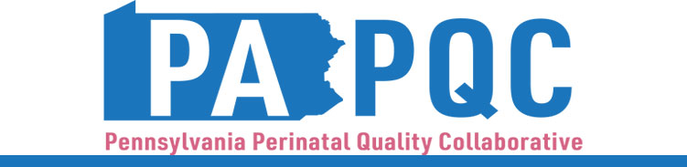

PA PQC Virtual Learning Session
Wednesday, December 11
11:00 a.m. to 12:00 p.m. ET
Virtual

Learning Objective:

- Discuss team successes and challenges in the areas of health equity, patient voice, and quality improvement participation.
Agenda:

11:00 a.m. to 11:05 a.m. – Welcome – Sara Nelis, RN, Program Manager, Jewish Healthcare Foundation

11:05 a.m. to 11:15 a.m. – Review of Designations – Sara Nelis, RN

11:15 a.m. to 11:25 a.m. – Quality Improvement Participation – Lisa Boyd, BA, PQC QI Coach & Data Manager, Program Associate, Jewish Healthcare Foundation and Jennifer Condel, SCT(ASCP)MT, Manager of Lean Healthcare Strategy and Implementation, Jewish Healthcare Foundation

  - Milestone 5 examples
  - Action planning tool review
11:25 a.m. to 11:55 a.m. – QI Peer-to-Peer Sharing: Designations Project Progress – Facilitated by Kristen Brenneman, MSN, RNC-NIC, Quality Improvement Facilitator, Jewish Healthcare Foundation and Hadar Re’em, Program Associate, Jewish Healthcare Foundation

  - Holy Redeemer Hospital: Helene Coakley, BSN, RN, OB Substance Use Disorder Nurse Navigator, presenting on Patient Voice in Maternal OUD
  - Armstrong Center for Medicine & Health Hospital: Kristina Lynch, BSN, RN, PHRN, Infection Control Manager and Lindsay Feitknecht, BSN RN, Nurse Manager 3A-OB, ACMH Hospital, presenting on Patient Voice in Safe Sleep
  - Penn Medicine Chester County: Stephanie Schwartz, DPT, NTMC, CNT, Lead Physical Therapist NICU and Dr. Jason Komasz, MD, FAAP, Medical Director, CHOP Newborn and Pediatric Care at Penn Medicine Chester County Hospital, presenting on Patient Voice in NAS Huddles & Neonatal Advocacy Group (NAG)
  - Trinity Health St. Mary Medical Center: Elizabeth Buck, BSN, RNC, C-EFM, presenting on Sepsis Health Equity Project

11:55 a.m. to 12:00 p.m. – Wrap-up & Next Steps – Sara Nelis, RN

