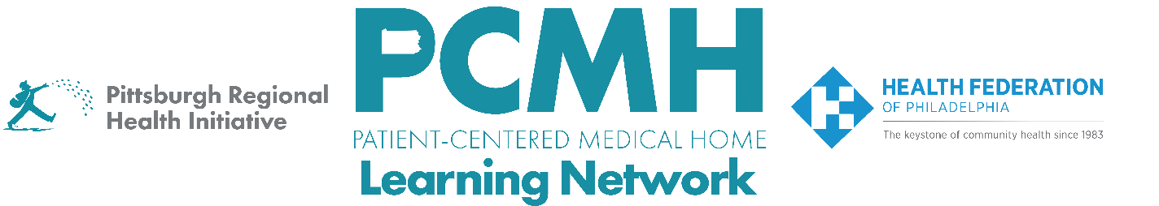
HealthChoices PCMH Learning Network
Quality Improvement for Blood Pressure Control and Asthma Medication Ratio
Tuesday, February 18 at 1:00 – 2:30 p.m. via Zoom

Register: https://us06web.zoom.us/meeting/register/SHgKkNE_QL6pmf_gr9Xe0w

Learning Objectives:

- Establish a shared understanding of the 2025 PCMH Sprint goals and framework for addressing blood pressure control and/or asthma medication ratio.
- Define the key intervention each PCMH is implementing and next steps for making progress.
- Identify the root cause(s) to address as part of each respective key intervention.
- Describe practices that enhance the current approach to managing hypertension.

Agenda:

1:00 p.m. to 1:10 p.m. – Welcome & Presentation of the overall plan for the 2025 sprint, including goals, the description of the measure, and the quality improvement framework
- Share context for the measures.
- Describe HEDIS measures, Controlling High Blood Pressure and Asthma Medication Ratio
  - Controlling High Blood Pressure assesses the percentage of members ages 18− 85 years who had a diagnosis of hypertension (HTN) and whose blood pressure was adequately controlled (<140/90 mm Hg) during the measurement year
  - Asthma Medication Ratio assesses the percentage of members ages 5−64 years who were identified as having persistent asthma and had a ratio of controller medications to total asthma medications of 0.50 or greater during the measurement year.

1:10 p.m. to 1:20 p.m. – Q&A

1:20 p.m. to 1:40 p.m. – Peer to Peer Sharing
Breakout rooms to discuss root causes and associated interventions
  - Two dedicated to BP
  - One dedicated to Asthma

1:40 p.m. to 1:50 p.m. Breakout Takeaways

1:50 p.m. to 2:20 p.m. –Hypertension Control Change Package with Q&A– Debra McGrath, MSN, FNP, President, DPM Healthcare Consulting

2:20 p.m. to 2:30 p.m. – Sprint Timeline, Next Steps & Evaluation

